**Social Media (Neparu) for**

**exploring together**

By Sudish basnet

UoN student number (18413692)

Supervisor : Pankaj Dawadi

Submitted in partial fulfillment of

the requirements for the degree of

BSc (Hons) Software Engineering

UNIVERSITY OF NORTHAMPTON

**May 2020**

**Video Demo URL : https://northampton.mediaspace.kaltura.com/media/Dissertation+demo/0_hd8babcx**

\

**Social Media (Neparu)**

By Sudish basnet

Submitted in partial fulfillment of

the requirements for the degree of

BSc (Hons) Software Engineering

UNIVERSITY OF NORTHAMPTON

**October 2019**

Contents

Acknowledgement 4

ABSTRACT 4

1 Dissertation Introduction 4

1.1 Background 4

1.2 Rationale 5

1.3 Aims and Objectives 5

1.4 Literature Review 6

1.5 Project Methodology 6

1.5.1 Requirement Engineering and Solution Specification 6

1.2.1 Elicitation Activities 7

1.2.1 System Analysis and Design 8

1.2.2 System Implementation or Construction 8

1.2.3 Testing 10

1.2.4 Evaluation 10

1.3 Ethical Considerations 10

1.4 Legal Considerations 10

2 Requirements Engineering 12

2.1 Elicitation Activities 12

2.1.1 Background Research 12

2.1.2 Comparable System 12

2.1.3 Interview Plans and Findings 17

2.1.4 Research papers, articles and journals review 17

2.1.5 Ethnography Research 21

2.2 Requirements Specification 21

2.2.1 Problem Domain 21

2.2.2 Functional Requirements 24

2.2.3 Performance Requirements 24

2.3.4 Design Constraints 25

3. System Analysis and Design 25

3.1 Preliminary Design Stages 25

3.1.1 Textual Analysis 25

3.1.2 Significant Event Analysis 27

3.2 Detailed System Architecture 28

3.2.1 BON diagram 29

3.2.1.1. BON system chart 30

3.2.1.2 BON Cluster Charts 31

3.2.2 Use case diagram 33

3.2.1 Class diagram 33

3.3 System Database Design 34

3.3.1. E-R Model 34

3.3.2 Database Attributes, Constraints, keys 35

3.4 Dynamic System Design 38

3.4.1 Events Charts 38

3.4.1.3 Object Creation Charts 39

3.4.1.4 Admin System Scenario Charts 39

3.4.1.5 Visitor System Scenario Charts 41

3.4.2 Dynamic Diagrams 42

4. System Interface Designs 43

4.1. Draft Interface Designs 43

4.1.1. Wireframes 43

4.1.2. Mock-ups 49

4.1.3. Event Diagram 61

4.1.3. Navigation Diagram 68

5. System Build and Technical Notes 69

6. Test Techniques 76

6.1 Real Time Testing 76

6.2 Unit Testing 77

6.3 Black box Testing 80

7. System Evaluations 85

8. Further Work 86

9. Project Conclusions 87

10. References 87

11. Appendix 91

11.1. Dissertation Progress 91

11.2. Interview questions and answers 91

11.3. Appendix 1 - Project Plan Gantt Chart 93

11.4. Presentation Slides 95

10.4. : Supervisor log 108

Table Lists :

Table 1 : Elicitation Activities 9

Table 2: Comparable System 14

Table 3 : Comparable system main GUI 16

Table 6: Rationale for issues and solution 24

Table 7 : System Management Privileges 26

Table 8 : Textual Analysis 27

Table 9 : Significant Event Analysis 29

Table 10 : User Table Attributes and Constraints 37

Table 11 : Post Table Attributes and Constraints 37

Table 12 : Photo Table Attributes and Constraints 38

Table 13 : Comment Table Attributes and Constraints 38

Table 14 : Inbox Table Attributes and Constraints 38

Table 15 : Notification Table Attributes and Constraints 39

Table 16 : Rental Table Attributes and Constraints 39

Table 17: Rental Photo Table Attributes and Constraints 40

Table 4 : Interview Plans and Findings 93

Flowchart Lists :

Flowchart 1 : Flowchart of System Architecture 31

Flowchart 2 : Flowchart of Login Process 63

Flowchart 3 : Rental Service Flow Chart 64

Flowchart 4 : Flowchart of Signup process 65

Flowchart 5 : Change Password Flowchart 66

Flowchart 6 : Chat Flowchart 66

Flowchart 7 : Add Post Flowchart 67

Flowchart 8 : Notification Trigger Flowchart 68

Flowchart 9 : System Online Blood Bank Flowchart 69

Flowchart 10 : User navigation panel 70

Flowchart 11 : Admin navigation panel 70

Figure Lists :

Figure 1 : Agile Methodology (Montana Ledger, 2019) 9

Figure 2 : Django pros and cons (Team,2019) 11

Figure 3 : JS pros and cons (Team, 2019) 11

Figure 4 : Blood request in existing system (Source : Facebook) 25

Figure 5 : Request for flats in existing system ( source : Facebook) 25

Figure 6 : BON diagram 32

Figure 7 : Use case diagram 35

Figure 8 : Class diagram 36

Figure 9: ER diagram 36

Figure 10: Login Wireframe 46

Figure 11: Signup Wireframe 46

Figure 12: Post feed Wireframe 46

Figure 13 : Upload Post Wireframe 47

Figure 14 : Info update Wireframe 48

Figure 15 : Search friend(Sathiharu) Wireframe 48

Figure 16 : Message Box Wireframe 49

Figure 17 : Change Password Wireframe 49

Figure 18 : Mobile customization Wireframe 50

Figure 19 : Mobile customized user page Wireframe 50

Figure 20 : Mobile Customized Blood Request Wireframe 51

Figure 21: Login Mock-up 51

Figure 22 : Signup Mock-up 52

Figure 23 : Navigation bar mock-up 52

Figure 24 : Info Update Mock-up 53

Figure 25 : Post feed , Gallery Mock-up 53

Figure 26 : Post details Mock-up 54

Figure 27 : Post edit Mock-up 54

Figure 28 : Inbox Mock-up 55

Figure 29 : Message Box Mock-up 55

Figure 30 : Rental Service Mock-up 56

Figure 31 : Blood Request Mock-up 56

Figure 32 : Search Friend ( Sathiharu) Mock-up 57

Figure 33 : Mobile Customized User Page Mock-up 57

Figure 34 : Mobile Customized Notification Mock-up 58

Figure 35 : Mobile Customized Message Box Mock-up 59

Figure 36 : Mobile app blood request Mockup 60

Figure 37 : Mobile customized explore mock-up 60

Figure 38 : Admin onboard panel mock-up 61

Figure 39 : Admin page Mock-up 62

Figure 40 : Admin page layout for user panel mock-up 62

Figure 41 : Database engine connection 72

Figure 42 : Setting up static files 72

Figure 43 URL patterns 72

Figure 44 : Abstracting default user 73

Figure 45 : Creating new Model 73

Figure 46 : Creating new Form 73

Figure 47 : Recall function with script 74

Figure 48 : Serializer 74

Figure 49 : Function with serializer and JsonResponse 74

Figure 50 : Receive Notification with JS 75

Figure 51 : Ajax with JS for like 75

# Acknowledgement

Developing a web app is not a headache part as it will be interesting step by step if you plan well with proper requirement engineering. With the development of web app Neparu, writer have learned the technique from each programming languages like python, JavaScript , html with frameworks like Django, bootstrap etc. With the evaluation of system after the completion the developer and some of the beginner users are happy with the helpful platform. Moreover, the process of implementation in new environment with new programming languages with framework have helped the writer to explore his knowledge and writing report for about the software development enhance his skills on this field of engineering considering the boundaries which shouldn’t be crossed during and after system development like legislations act and rules. For the success of this project, writer specially thanks the module leader and supervisor for supporting and providing enough resources which helped a lot to dig insight view for a system development dealing with real time issues and special thanks to interviewee and evaluator to help system get justified.

# ABSTRACT

Social networking sites are the biggest platforms for everyone in this era of technology. There are many networking sites or apps currently running and are very much popular like Facebook, Instagram, twitter etc with their individual preferences . Beside the popularity of these medias, they lack some features like blood donation or request and rental services which are the biggest issues for now due to increasing population. Though there are few sites for blood related programs and rental sites, but the fact is they are not much interesting which leads users to not enrol properly and they might forget sometime later whether the system still exits . So, the development of this app with the purpose of dissertation which is given title as Neparu will lead to new turn with the interesting functionalities to explore people with new connections and beside that there will be main functionalities solving real time issues which are so much common for every one of us. All the existing social networking sites are so busy with their advertisement management that there are millions of people creating pages in Facebook for rental services or blood request which are not that much genuine. Therefore, this web app development will take a new turn carrying some responsibilities and making life much easier with some entertainment solving real time issues.

# 1 Dissertation Introduction

## 1.1 Background

Today is the generation of internet where every possible information about everyone is stored online. Though there are many social media till date but only few of the medias are implemented here in Nepal, which were later changed to online shopping and some were closed due to poor requirement engineering and popularity. According to my own research ,I been through many of my friends who search for rooms, flat as well as house to take for rent and here arises the real problem so this social media(Neparu) will also have the platform to check for rents according to their area beside the fact of social networking site where users can also share their information like posts interactions, messages etc which makes this system more user friendly and interesting. Second problem which is happening right now is accidents with the increasing rate per day where many victims are dying due to lack of blood availability and management, so in this social media users can enter their blood group and whenever someone is in need then user who knows about accident can themselves ask for blood where the related persons with same blood group and users who haven’t set blood group will be notified via notification system in this social networking app.

## Rationale

With the use of this social media (Neparu) users can entertain themselves and able to explore as well as make new connections, beside this, with the information users have entered in the system about the places for rent or sell many of the people who are in search can save their time as well as brokers working for it where people have to give extra money will be saved. Another fact about the increasing rate of accident where with the data collected about the blood group from this system users, victims can easily get blood for recovery with the notification system to everyone whose blood group matches.

## Aims and Objectives

Beside the fact of this project which is a social networking site where users can interact with each other and explore them with some entertainment which would be the basic features of the system, the main motive of this project is to help the victims who got injured from accident as well as other people who are in need through the donor with the medium of this system with proper information for blood requests. Also, the next goal apart from blood managing this project also leads to help many people who are in search for rents as well as buy a space without the need of going through mid-person or broker according to their space requirement specification.

In order to succeed the aim of this project so that each individual user can get benefit, there are certain objectives which should be taken ,they are listed below:

* Research for real time issues and check whether it is reliable or not
* Provide proposal to the supervisor
* Improvise a suitable requirement engineering after acceptance from supervisor
* Carryout the elicitation work
* Research based on other social media regarding the problem
* Know if this project already been investigated by others
* Check for comparable system and get insight view
* Background research with research papers and journals
* Legal and ethical consideration relevant to system
* Identify potential software development methodology
* Identify potential software development tools like virtual environment, programming language, frameworks
* Carryout requirement specification
* Justify solution for the problem domain
* Finalize functional requirements
* Finalize performance requirement
* Consider design constraints and commercial constraints
* Analysis of system design
* Finalize predicted system attributes, classes and events
* Prepare draft designs about system workflow
* Prepare system interface designs with wireframe, mock-ups and system flow charts
* Implement system with provided information with real time testing
* Carryout system testing and evaluation
* Conclude the system development progress

## Literature Review

This project will be implemented after the research done towards the social medias which are leading today’s world rapidly. Not only solving the problem that are arising, but this research includes the interaction between users in social platform with their own terms of entertainments.

While starting this system, creation of account will need no more than couple of minutes. Users can upload posts, view posts and act on them through likes and comments. Everyone can follow people of their interest and unfollow as well. Chatting with each other is much more comfortable through the social platform and explore themselves with world. In case of emergencies when blood needed, with very simple step users can ask for blood and other users can confirm if available which leads to great benefits. As well as, users can choose spaces for rent or to buy without going through mid-person.

## 1.5 Project Methodology

For the research development to complete the project with success and usability, following areas should be in action:

### 

### 1.5.1 Requirement Engineering and Solution Specification

For the collection of data which is then to be performed during and after the implementation of project, agile methodology is used where a weekly interaction with the supervisors and the common people who are going to be users are asked questions and discussed over relevant topics followed by requirement engineering techniques.

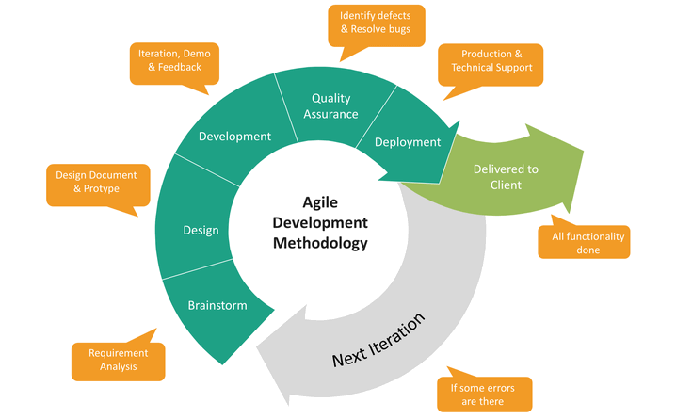

Figure 1 : Agile Methodology (Montana Ledger, 2019)

### 1.2.1 Elicitation Activities

To ensure more understanding to problem domain, this strategy is required so that all the required information will be collected as discussed in literature review , background research and project rationale.

Table 1 : Elicitation Activities

|  |  |  |  |
| --- | --- | --- | --- |
| **Techniques for Elicitations** | **Advantages** | **Disadvantages** | **Justifications** |
| **Background Reading** | Easy to gather information and data from the online medium or either from the journals. | Sometime information provided online or maybe journal may be outdated . | As already discussed about this strategy while doing literature review , it will greatly impact on a good system build. |
| **Questionnaires** | Through the medium of online or direct conversation, issues related to social networking sites can be obtain easily which will help later to interview also. | Using Technical terms while gathering info can be difficult . | Enough information can be gathered through this process as the number of users for social networking medias is higher. |
| **Interviewing** | Questions collected after questionnaires can be recalled and help to discuss with the interviewee for more details. | Without the good preparations and compatible question, interviewee may not be able to give all the info as expected. | As many people relate to social medias which is already in use, they may justify the question which are arising. |
| **Task Observation** | Deep understanding of existing system to document some details | * Rarely accurate * Time consuming | Choosing this technique help to organize overall idea for system development. |
| **Ethnography** | Developer can clearly understand about the problem domain. | Time consuming and Expensive to apply when needed. | As everyone is familiar with social medias, such expensive strategy will not be needed. |

### System Analysis and Design

To design the system programming languages like JavaScript, html, CSS, jQuery, and tools like photoshop for some logos and pictures will be used ad some online wireframe and mock-ups maker to design system before implementing with code. Some social medias will also be referenced out for more accuracy and data collection. Research will still be continuing till the implementation complete, as it might help to upgrade some ideas as needed according to the update. Database design will be made with the data collected which is then considered for making ERD and enlisting attributes. After all the designs and implementations some testing will be carries out for system accuracy and reliability.

### System Implementation or Construction

As explain in the problem domain investigation and system analysis and design programming language like python, Django framework , JavaScript, html, CSS, jQuery, bootstrap will be used. Before implementation with coding, some flowchart and algorithms will also be carried out to follow the process that how the system will work and know what the exceptional cases are. Regrading Django with python and other usable programming languages for this system, their pros and cons are delivered below through figures.

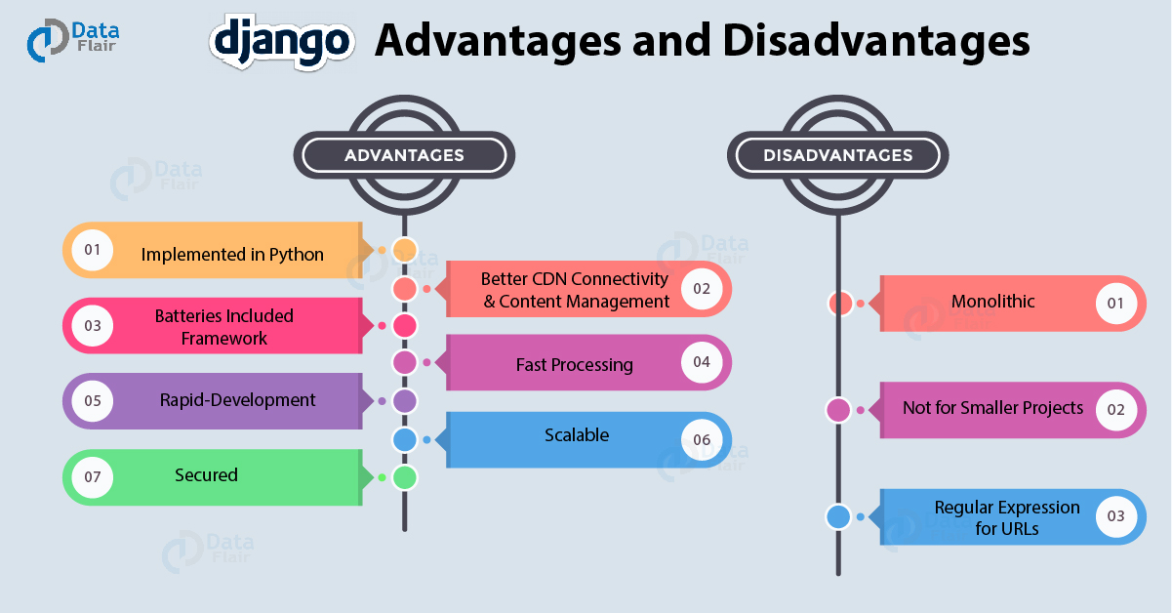

Figure 2 : Django pros and cons (Team,2019)

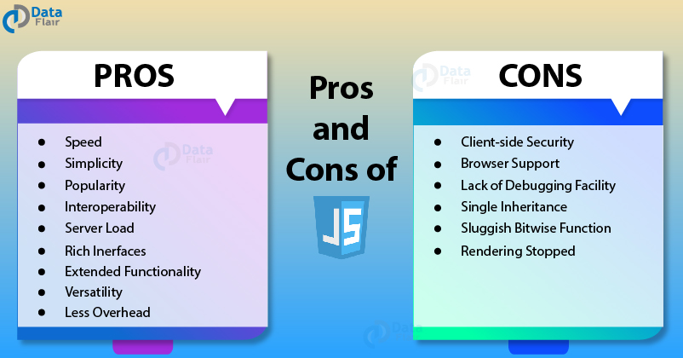

Figure 3 : JS pros and cons (Team, 2019)

### Testing

To get an accurate and well-functioning system, following strategies are followed out while doing the implementation and after the completion.

#### Real-time Testing

This is the ongoing phase which will be carries out throughout the implementation process where the system will be tested out every single time when there is some update in the system. This helps in further redundancy of error while completion of system, as without this technique the system completion may take time due to the errors which are happening at the completion phase where the programmer need to look throughout the whole system from the beginning to find a single error.

#### Unit Testing

In this phase of testing after the completion of system implementation, test will be carried out covering all the internal functions if they work good without error with different types of data either valid or invalid.

#### 1.2.3.3 Black-box Testing

Black box testing which can also be referred as behavioural testing is carried out for testing of inputs and outputs of system without knowing the structure of system with both valid and invalid data following some test cases.

### Evaluation

To know whether the system is built as expected or not, evaluation strategy is followed out with the practical use.

#### Feedback reports and System Evaluation

In this phase after the completion of the system development few of the common users will give the environment where the problem will be rises according to the real world and hence the users will interact with the system and give us their feedback and queries.

## Ethical Considerations

Users during trail should be given freedom to justify themselves with the system for accessing every feature and can query if needed.

## Legal Considerations

Some of the legal act that should be followed out throughout the implementation and after the implementation for further use so that none get harm with this system are like:

* **Computer Misuse Act** 1990 (Legislation.gov.uk, 2019)

Some offences taken from legislation of uk government that should be considered while developing a system or software are:

1. Unauthorised access to computer material.

2. Unauthorised access with intent to commit or facilitate commission of further offences.

3. Unauthorised acts with intent to impair, or with recklessness as to impairing, operation of computer, etc.

3ZA.Unauthorised acts causing, or creating risk of, serious damage

3A.Making, supplying or obtaining articles for use in offence under section 1, 3 or 3ZA

* **Data Protection Act 2018** (GOV.UK, 2019)

The [Data Protection Act 2018](http://www.legislation.gov.uk/ukpga/2018/12/contents/enacted) controls how your personal information is used by businesses or the government. Everyone responsible for using personal data has to follow strict rules called ‘data protection principles. They must make sure the information is:

* used fairly, lawfully and transparently
* used for specified, explicit purposes
* used in a way that is adequate, relevant and limited to only what is necessary
* accurate and, where necessary, kept up to date
* kept for no longer than is necessary
* handled in a way that ensures appropriate security, including protection against unlawful or unauthorised processing, access, loss, destruction or damage

There is stronger legal protection for more sensitive information, such as:

* race
* ethnic background
* political opinions
* religious beliefs
* trade union membership
* genetics
* biometrics (where used for identification)
* health
* sex life or orientation

* **Copyright, Designs and Patents Act 1988** (Service, 2019)

The Copyright, Designs and Patents Act 1988, is the current UK copyright law. It gives the creators of literary, dramatic, musical and artistic works the right to control the ways in which their material may be used. The rights cover: Broadcast and public performance, copying, adapting, issuing, renting and lending copies to the public. In many cases, the creator will also have the right to be identified as the author and to object to distortions of his work.

Copyright arises when an individual or organization creates a work and applies to a work if it is regarded as original, and exhibits a degree of labor, skill or judgement.

# Requirements Engineering

## 2.1 Elicitation Activities

In this section all the background research and the problem domain found in existing system will be justified with their limitation and the approaches that is to be followed so that system development will be according to need and everyone can get benefit by this solution system.

### 2.1.1 Background Research

Author had gone through couples of research with in-use online networking system like Facebook, Instagram, Twitter, HamroBook.com which is clone of Facebook but built in Nepal. The research outcomes with the in-use systems is pointed out in the comparable system below.

### 2.1.2 Comparable System

In this section, some of the systems like this are compared and extracted information to know about their pros and cons so that it will be easier while implementation to give the strong justice for the new system with these cons.

Table 2: Comparable System

|  |  |
| --- | --- |
| **Systems in Use** | **Descriptions** |
| **Facebook / HamroBook.com** (HamroBook is the clone of Facebook but implemented in Nepal) | More than 1 billion people use Facebook.  **Pros:**   * Takes 3-4 minutes to setup account with signup process which is not time consuming. * Recommends users to connect with the help of mutual friends * Easier to chat and send mms * User can share stories of their daily life which is implemented after Instagram * Easy to Advertise   **Cons:**   * Loss of copyright to pictures and posts * Malware and viruses * Identity theft * Antisocial behaviour   (It Still Works, 2019) |
| **Instagram** | More than 100 million people use Instagram.  **Pros:**   * Takes as much time as Facebook does but can be signup with the Facebook account too, so it is also not time consuming. * Recommends posts by users according to search list * User can share stories of their daily life * Easy to Advertise * In-app mobile shopping   **Cons:**   * So called free tools and analytics are not actually free * Loss of copyright to pictures and posts * Availability limitations as compared to different medium to using Instagram   (Just Web World, 2019), (Olson, 2019) |
| **Twitter** | More than 330 million actives users  **Pros:**   * Takes as much time as Facebook and Instagram does so, it is also not time consuming. * Can tweet with #hastang power to reach with many users and see others tweets according to interest * User can tweet with the time schedule for it * User can create mini news feed and can join to others curated group   **Cons:**   * Twitter is busy with 340 million of tweets per day * Character limit of 140 to express thoughts * Spamming, which is to be self-aware * Followers limitations in case if you have 100 followers then you can follow 10,000 users.   (Hernández, 2019) |
| **Reddit** | More than 330 million actives users  **Pros:**   * Takes almost same processing time as Facebook ,Instagram and twitter does so, it is also not time consuming. * User can share their voice with others * User can put themselves in position to meet other users having same thought. * User can join in a running thread whether user is new to it or not which is fun too.   **Cons:**   * The feature of AMA if catches user then it will be uneasy to response every question asked due to tight schedule * Many times, individual thought can be disputed by other users as audience which cannot be changed or reported as it is the process of the system. * It is not sure that everyone will participate in individual AMA which is not satisfying at all. |
| **gharbazar** | Few 100 peoples are active users  **Pros:**   * Cannot directly contact the space owner * Slow response from the real estate agent   **Cons:**   * Not interesting to check the posts due to which users’ number is less and current users might forget later about the system. * Cannot connect or interact with other users |
| **American Red Cross** | More than thousands of active users  **Pros:**   * Users are notified for new blood campaign by the company. * Users can get appointment through this system to the company. * User can know more about blood donation and its advantages   **Cons:**   * Cannot individually ask for blood request. * Cannot connect or interact with other users * Cannot notify user about blood campaign by users. * Not interesting to explore although it is not meant to be interesting for such system but for the active users it might get them bored. |

Table 3 : Comparable system main GUI

|  |  |
| --- | --- |
|  |  |
| Reddit Source : Reddit | Instagram Source : Instagram |
|  |  |
| Facebook source : Facebook | Twitter source : Twitter |
|  |  |
| Ghar Bazar source: gharbazar | American red cross source: American Red Cross |

In the above table, the layout of few existing social networking sites is given where most attractive seems to be reddit. The basic concept of every system is featuring the content in the centre where the system properties for navigation or information is shown either top, right or left.

### 2.1.3 Interview Plans and Findings

Though many information’s regarding existing system and problems are find out but to recall all the question, interview plan is done. The brief discussion about the interview with every questions and answers is given in appendix with table.

The overall outcome from the interview done was that every existing users for exiting system are satisfied with what they have served beside some compromising which are done by users like limited features, a lot of advertisement, unable to find solution for real time issues etc. But with the compromising they made, they believe that social media have made their life more ease when it comes to utilize time for making new connections and exploring themselves. Not everyone but majority of interviewee got problem regarding rental service as well as blood donation and they want to see those to be covered from new system development and that is exactly our system motive and theme of this dissertation.

### 2.1.4 Research papers, articles and journals review

For the best insight view of how the system features are going to treat with real world and knowing the strategies that can be follow up for making the count of users in future expand, this research can help a lot. Not only helping to strategies for the system development, it also leads to investigate the greater insight view for current affairs and problem domain with solution.

**1. Predicting tie strength with social media** (Gilbert and Karahalios)

According to this research paper published at Urban-Champaign University of Illinois, writer have abstracted that “Social media treats all users the same: trusted friend or total stranger, with little or nothing in between”. Under the theme of tie strength, social science is investigated where along this spectrum, relationships fall everywhere in reality. In this research paper writer have witnessed model which is predictive for mapping social media data to tie strength with a dataset of 2000+ which performs quite well identifying between pros and cons over 85% accuracy. The writer has complemented the quantitative findings through interviews which unpacked the relationship unexpectedly. For the social media design, they have suggested that how tie strength model can help to improvise social medias elements covering normal activity events like message routing, privacy, friends routing, and every information related to a user.

Below is the figure which was used during the process of the following research by the writers where the questions below were for the purpose of assessing the tie strength which was embed into profile of friends as participants for the research . When participants answer the questions then script collecting data discovering the bond of friendship which reflect views on tie strength.

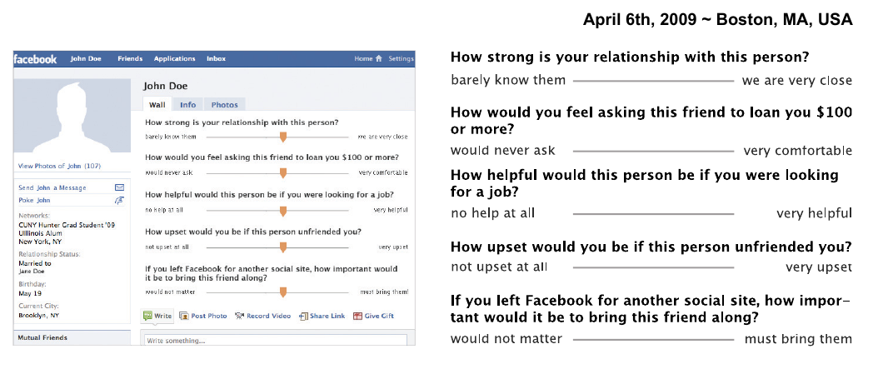

**2. Promoting blood donation: a study of the social profile, attitudes, motivation and experience of donors**[**\***](https://onlinelibrary.wiley.com/doi/abs/10.1111/j.1365-3148.1991.tb00034.x#fn1)(Moore)

This paper shows the study which was investigated to improve the number of blood donors’ participants and their constant holding as active donors so that they can be call up in necessary. According to Moore “A total sample of 9,000 non-donors, lapsed donors and current donors was examined in three programmes to determine the sex, age and social profile of donors; the attitudes of the population to blood donation; the motivating forces prompting people to give blood; the de-motivate forces preventing them; the image of the blood donor in society and the image of the National Blood Transfusion Service (NBTS)”. In this study, image of both NBTS and blood donors was founded positive and the main things that was holding the donors to be constant was that the need of blood can be personal someday so that NBTS strategy will then more focus on reinforcing for the need of blood donors sharing experiences for existing participants.

According to (Bruhin et al.) the response for donors who are called for the purpose was high that means with this medium of requesting blood through social media it will really impact the users to donate.

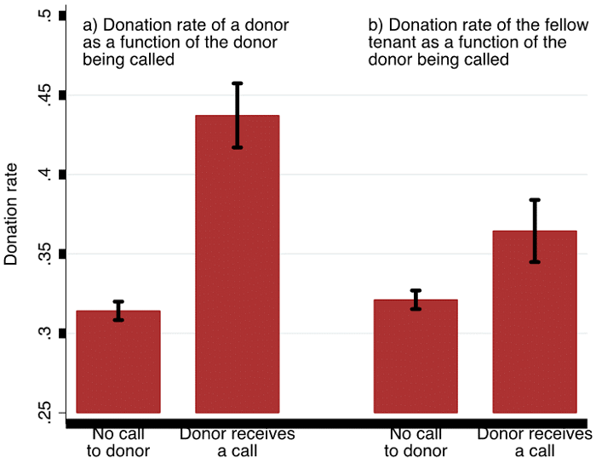

**3. Predicting the Future with Social Media** (Asur and Huberman)

In this research paper, writers have abstracted that the in recent years, social media has become ubiquitous and important for social networking and content sharing. The content that are published through these mediums are largely remains untapped. According to this paper writers have come to know how the data or information shared by users of social media like posts can be used to predict real world issues and outcomes where twitter was taken as subject for this research to know the box office revenue for movies with the use of chatter. Writers suggested that sentiments that are extracted from twitter can be used to demonstrate the sentiments and improve the prediction power of social medias or networking sites.

According to (Ortiz-Ospina) below is the figure which suggests the growth of peoples using social medias with the age group where 18-24 are the highly attracted users. As age group between 18-24 are very active for passing information so for the topic of dissertation, social media can really impact in a beautiful way to make awareness and help people in needy for blood requests.

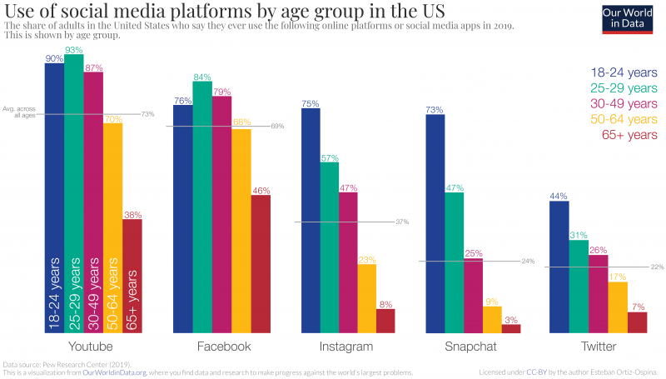

**4. Rental House Management System** (Gommans et al.)

According to the writer of this research paper, they have abstracted that people have stuck in between technology where people really want is the thing that works for them. Following the present paradigm shift with technology , writers stated that there is need urgent need for easy management of rental house either for each individual or rental managers . The overall research paper claims for the efficient and effective platform for rental services with the facilitate of modern technology. For the research purpose, writer have collected information from the rental managers that how the working process done which was result as workflow manually by them which is not a good way of storing data as paper can be damaged or lost. Writers have also listed the difficulty to get single file from a bunch of multiple files. Due to reasons of less efficient work, writers argue to develop a rental house management system which can solve the present issues with traditional methods.

So, this paper explains the need of rental service online system for renting space or buying it which was successful for their case and was very efficient with the increasing number of rents needed.

**5. BLOOD BANK MANAGEMENT SYSTEM** (RAUT et al.)

This journal explains the need of blood management system with the huge researches carried by the writer where they discussed about the increasing population throughout the world and with the multiplying population diseases and health issues are also increasing due to which there is increase in rate of need of blood. With the need of blood there are also the increasing rate of blood donors but due to poor communication gap between donors and receptors, only 10% of the world population is able to donate blood which is very poor in compare to need due to which a lot of beautiful life are dying. Because of such reason, this paper presents the high end of bridge which is gap between donors and people in need. This research justifies with the development of application for blood bank management system which is for the way of synchronizing blood banks and hospitals through internet.

The same concept which is raised by writers also matches the theme for this dissertation project which is requesting blood in need and get the roper detail of donors to contact for any future need.

### 2.1.5 Ethnography Research

While researching for the system process of any other comparable system already exists, Facebook is taken in observation. The process or events applied during using Facebook are:

* Signup with personal info and confirming with email verification after signup.
* Adding friends with their names in the first phase.
* Uploading profile if user wants to.
* User can now upload posts likes, comment posts.
* Chatting is enabled for added friend while if the user is not in friend list, the message will go to request list.
* User can create group

The process or events applied during using Instagram are:

* Signup with personal info and confirming with email verification after signup or signup with google or Facebook
* Following friends with their names in the first phase.
* Uploading profile if user wants to.
* User can now upload posts likes, comment posts.
* Chatting is enabled for added friend while if the user is not in friend list, the message will go to request list.
* User can create group in message.
* User can upload story.

## 2.2 Requirements Specification

In this section detail information and strategies will be draw out about the problem domain and system specifications or functionality.

### 2.2.1 Problem Domain

Though the points for problem domain is carried out already in the literature review as well as background research, in this section it will cover every reasons and possibilities for the reason for system implementation though there are other social networking sites already with millions of users.

Table 6: Rationale for issues and solution

|  |  |
| --- | --- |
| **Current System issues or lacks** | **Solution with Neparu** |
| As we all are familiar with Facebook, Instagram, twitter etc which are widely in use but somehow, they lack some features which can be refer down below with some points:   * Users using Facebook for making some pages or uploading posts to advertise about rental services which is not genuine and more attractive. * As being social networking site Instagram is there for only some advertisement, sharing daily stories and chatting with each other. * Users from Facebook are requesting for blood in case of emergencies through posts and messages which is not reachable with every people. | Not every problem but with some feature Neparu can solve few problems with the following strategies:   * Rental Service: This strategy helps many of the users to know about the available rental services. In this feature, user will get a platform to upload details about the space they have got and will be listed when some one’s requirement meets and easily book by the system process. * Asking Blood: This feature is mostly needed in today’s fast generation. The data of blood group is collected from possible users and when someone is in need then they can ask for blood which will be notified by every user with matching blood group in their location and people can confirm there. |

Some of the snaps from online networking sites are displayed below in order to justify the problem domain for this project with all the relevant information .

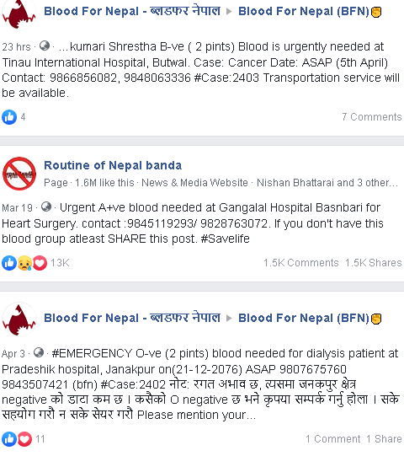

Figure 4 : Blood request in existing system (Source : Facebook)

Though people ask for blood but due to lack of boosting, it rarely spread over the internet and only few of people get notified and be aware of that. Some people take it as joke where it is important for someone.

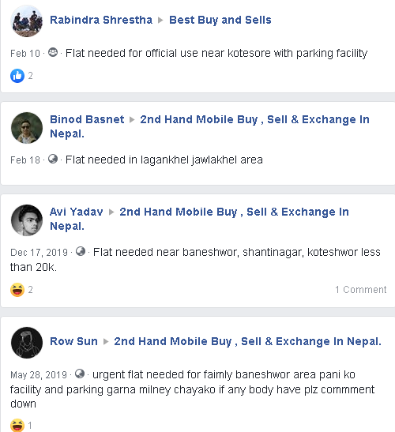

Figure 5 : Request for flats in existing system ( source : Facebook)

Many people still try to find rental spaces from Facebook and there aren’t able to get immediately due to poor platform for rental space and they need to go through broker in their local area to find spaces which is not preferable all the time.

### 2.2.2 Functional Requirements

After couples of research done to compare the on-going social networking sites, for the smoothness of this new system list of tasks are carried out in order to fulfil the necessity of the system features and events. To understand the functionality and events access, below is the tables for system privileges:

Table 7 : System Management Privileges

|  |  |  |  |  |
| --- | --- | --- | --- | --- |
| Colours |  |  | | |
| Privilege | Allowed or has Access | Not Allowed | | |
| **Events or Actions** | | | **Administrator** | **Users** | |
| Login | | |  |  | |
| View, Update, Search, Delete Users Data | | |  |  | |
| Add posts | | |  |  | |
| View, Update ,Report, Delete Posts Data | | |  |  | |
| Add , Update Notifications | | |  |  | |
| View Notification | | |  |  | |
| Chat | | |  |  | |
| Delete messages | | |  |  | |
| View, Update, Delete Rental Service | | |  |  | |
| Add , book, confirm rental services | | |  |  | |
| Update, Delete Blood Request | | |  |  | |
| Add blood request , Confirm, Cancel Blood Availability | | |  |  | |
| Like, Comment Post | | |  |  | |
| Follow, Unfollow User | | |  |  | |

### 2.2.3 Performance Requirements

No users will be satisfied if the system goes down every single time and have slower processing speed with some limitation of data uploads. To smooth these requirements, some of the key points will be highlighted throughout the implementation and after the completion.

#### 2.2.3.1 Speed

This system uses Django framework which has fast processing speed . As discussed in literature review to signup would only take less than 1 minute. This system covers feature for blood request, which is an emergency need, so that the database must managed properly, and the information should be displayed on time. Apart from the blood request event, chatting with friends needs to be much smoother with the speed of communication which is aimed to be 1 sec of system auto request for checking any unread messages.

#### 2.2.3.2 Reliability

As a Social networking site, it will be in use for 24 hrs for transferring data from one medium to another every time. Even some failures in the system after the implementation should take an hour as long with the backup provided for the user’s stability. So, this system can run smoothly beside some minutes breakdown for changing the backup server.

#### 2.2.3.3 Usability

As far as known to today’s system, the system should be understood by all the users either high skilled or poor skilled with the help of normal language and denotation of some highlighted text with some figures.

#### 2.2.3.4 Capacity

With the requirement of speed, reliability and usability, system needs a quality processor and a high space disks so that data uploaded should store in the system if users deletes or expires by itself. As social networking sites are rapidly growing sites, it needs some backup for the storage whenever needed for the system upgrade or failures cases. This system will be able to store around 2000 user’s data for now with small server.

#### 2.2.3.5 Security and Privacy

Many users tend to secure their information and keep their privacy so that the system will not give access to other users about their info if users wants. Passwords are hided and some controversial information too. Every event in the system needs user authentication.

### 2.3.4 Design Constraints

Design constraints for this system after all the research is highlighted below:

* Front end of the system which will be viewed by the users which will be designed with HTML, CSS, Bootstraps, JS.
* Back end will be designed with Python with Django
* Relational database will be used with SQLITE3 engine.
* If users input wrong inputs, system will show the error clearly
* Colours to be in use by the system will be practically selected on the basic of eye friendly colour.

# 3. System Analysis and Design

## 3.1 Preliminary Design Stages

### 3.1.1 Textual Analysis

For deriving useful information and know about initial class structure from the system, requirement specification is broken down with some keywords or phrases to describe.

Table 8 : Textual Analysis

|  |  |  |
| --- | --- | --- |
| **Classes** | **Action** | **Main Attributes** |
| Inbox / Chat | * Send * Receive * View * Process | * Sender * Receiver * message |
| Post | * Add post * Delete post * Update * Like * Comment * View * Report | * Caption * Photos * Post id * Comment content |
| Follow | * Add * Delete | * User |
| Blood Request | * Add request * Delete * Confirm * Cancel request, availability * view | * blood_group * location |
| Rental | * Add * Update * Delete * Book * Cancel booking * view | * location * description * space number * photos * cost * title |
| Notification | * Add * View | * Notification_id * Content * description * Action * Blood * Post * Rental |
| Users | * Add * Update * Delete * Search * Follow | * Username * Userid * Firstname * Lastname * Contact * Mail * password |
| Comment | * Add * Update * Delete | * Post id * Comment id * Action name |
| Feedback | * Add | * message |

### 3.1.2 Significant Event Analysis

To know the actors and their roles for determining the system functionality significant event analysis is taken in action.

Table 9 : Significant Event Analysis

|  |  |  |
| --- | --- | --- |
| **Events** | **Performer** | **Main Attributes** |
| Login | * Admin * User | * Username * Password |
| Settings | * Admin * User | * Settings forms |
| Add: User | * Admin * Nonuser | * Username * Firstname * Lastname * Mail * Password |
| Update: User | * User | * Firstname * Lastname * Bio * Blood_Group * Password * Privacy |
| Chang password | * Admin * User | * Current password * New password * Confirm password |
| Delete: User | * Admin | * Username * User_id |
| Add: Post | * user * admin | * caption * photos |
| Add: Comment | * user | * user * content |
| Send, Receive : Message | * User * Admin | * Sender/receiver * Message |
| Add : Blood request | * User | * Blood_group * Description * Location |
| Add: Rental | * User | * location * description * space number * photos |
| Add : Notifications | * Admin | * Content |

## 3.2 Detailed System Architecture

In this section, the architecture of the system with clear graphical representation will be demonstrated. Below is the flowchart about the system that what are the events and what is the process to access as performer . In the below flowchart some events are not given like reporting post, message and few more which are explained in other detailed static and dynamic system figures and charts.

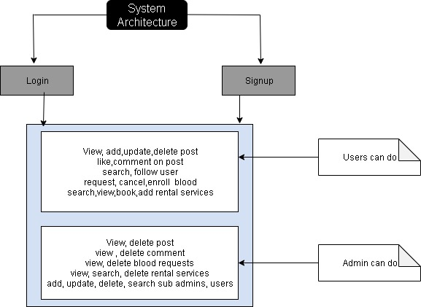

Flowchart 1 : Flowchart of System Architecture

### 3.2.1 BON diagram

Below is the system architecture diagram which is also called as BON diagram that shows the system behaviour for developer as well as the users or client to get specified information.

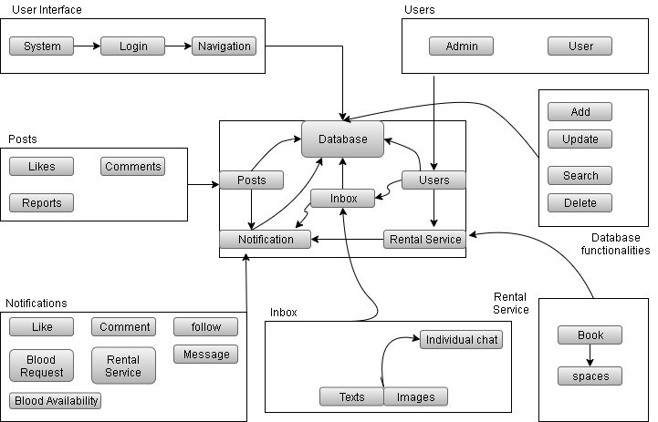

Figure 6 : BON diagram

### 3.2.1.1. BON system chart

|  |  |  |
| --- | --- | --- |
| **SYSTEM** | | **Neparu** |
| **PURPOSE** : Social media with the information of users and their actions with some extra features information’s which people usually need. | | |
| **CLUSTER** | **DESCRIPTION** | |
| USER INTERFACE | System start-up panel where users can access the system functionalities with their ids. | |
| DATABASE | Records of every class and attributes of the system. | |
| NOTIFICATIONS | Announcement of some events related to users. | |
| INBOX | Management for user’s communication | |
| RENTAL SERVICE | Management with the information’s about the rental services | |
| POSTS | Users shared phots and their opinions information | |
| USERS | Class with the privilege of accessing system | |
| DATABASE FUNCTIONALITIES | The CRUD operation for all the classes | |

### 3.2.1.2 BON Cluster Charts

|  |  |  |  |
| --- | --- | --- | --- |
| CLUSTER | User Interface | | Part:1/1 |
| PURPOSE: Start-up for the system | | INDEXING  Author: Sudish Basnet | |
| Class | | Description | |
| System | | First opening panel for the system | |
| Login | | Authentication panel for user access | |
| Navigation | | User panel | |

|  |  |  |  |
| --- | --- | --- | --- |
| CLUSTER | Database functionalities | | Part:1/1 |
| PURPOSE: Start-up for the system | | INDEXING  Author: Sudish Basnet | |
| Class | | Description | |
| Add | | Creation of new information’s | |
| Update | | Action for existing data | |
| Search | | Query event | |
| Delete | | Action for removing from the database | |

|  |  |  |  |
| --- | --- | --- | --- |
| CLUSTER | Notification | | Part:1/1 |
| PURPOSE: Event triggered information | | INDEXING:  Author: Sudish Basnet | |
| Class | | Description | |
| Blood request | | Information of the blood request event | |
| like | | Information of the posts liked | |
| Comment | | Information of the posts commented | |
| Follow | | Event information of user interaction | |
| Message | | Event information of user’s communication | |
| Rental Service | | Event information of rental spaces | |

|  |  |  |  |
| --- | --- | --- | --- |
| CLUSTER | Users | | Part:1/1 |
| PURPOSE: Users information | | INDEXING:  Author: Sudish Basnet | |
| Class | | Description | |
| Admin | | User with highest privileges in the system | |
| User | | User with the information related to him | |

|  |  |  |  |
| --- | --- | --- | --- |
| CLUSTER | Inbox | | Part:1/1 |
| PURPOSE: Communication between users | | INDEXING:  Author: Sudish Basnet | |
| Class | | Description | |
| Individual | | System accessibility for chatting | |
| Texts | | Information to be transferred | |
| Images | | Real time photos | |

|  |  |  |  |
| --- | --- | --- | --- |
| CLUSTER | Posts | | Part:1/1 |
| PURPOSE: Posts events | | INDEXING:  Author: Sudish Basnet | |
| Class | | Description | |
| Like | | Posts information with user’s interaction | |
| Comment | | Posts opinions with user’s interaction | |
| Report | | Posts bad opinion by users | |

|  |  |  |  |
| --- | --- | --- | --- |
| CLUSTER | Rental Service | | Part:1/1 |
| PURPOSE: Rental event | | INDEXING:  Author: Sudish Basnet | |
| Class | | Description | |
| Book | | Action taken by the interactors | |
| Spaces | | The information about the posted spaces | |

### 3.2.2 Use case diagram

Representation of user relationship with different use cases in simplex form for this system.

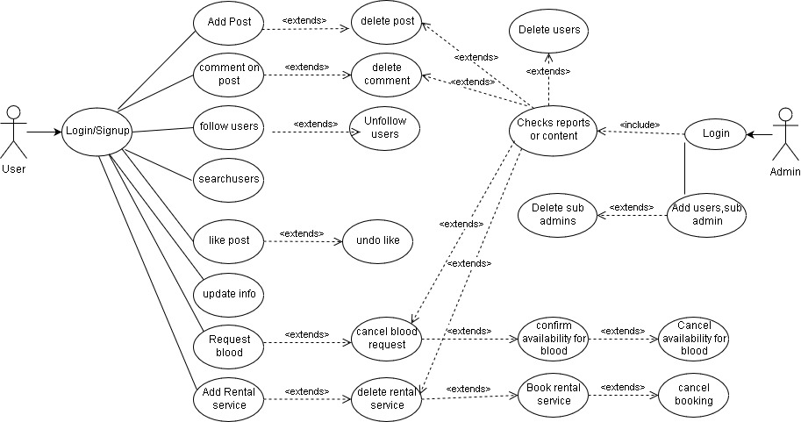

Figure 7 : Use case diagram

### 3.2.1 Class diagram

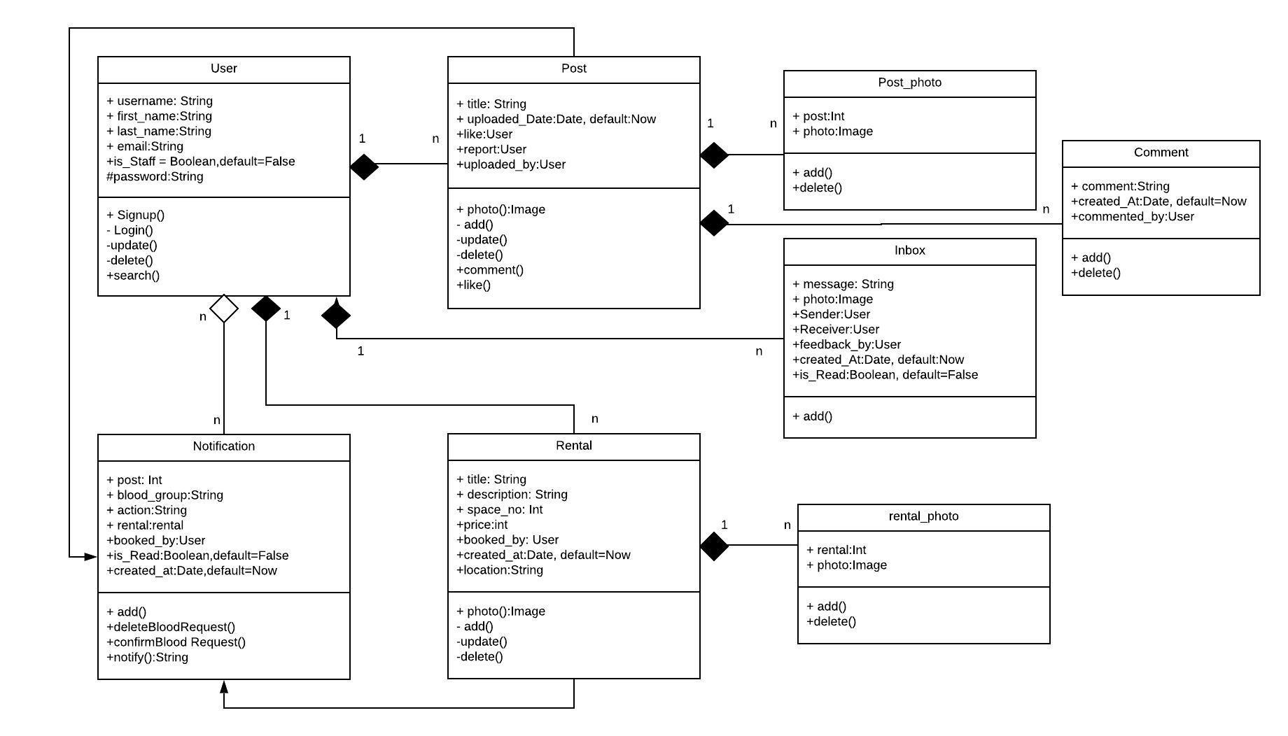Class diagram represents the class member such as attributes and method which in additional shows the system behaviour. With the help of class diagram, it makes the software development more efficient. Below is the finalize class diagram for this system.

Figure 8 : Class diagram

## 3.3 System Database Design

In order to implement functionality to the system database structure should be managed correctly. For this system relational database is used with the database engine SQLite3. SQLite is an in-process library that implements a [self-contained](https://www.sqlite.org/selfcontained.html), [serverless](https://www.sqlite.org/serverless.html), [zero-configuration](https://www.sqlite.org/zeroconf.html), [transactional](https://www.sqlite.org/transactional.html) SQL database engine. The code for SQLite is in the [public domain](https://www.sqlite.org/copyright.html) and is thus free for use for any purpose, commercial or private. SQLite is the [most widely deployed](https://www.sqlite.org/mostdeployed.html) database in the world with more applications than we can count, including several [high-profile projects.](https://www.sqlite.org/famous.html) (Sqlite.org, 2019)

### 3.3.1. E-R Model

Below is the entity relationship model diagram to describe about the relations between entities used in the system.

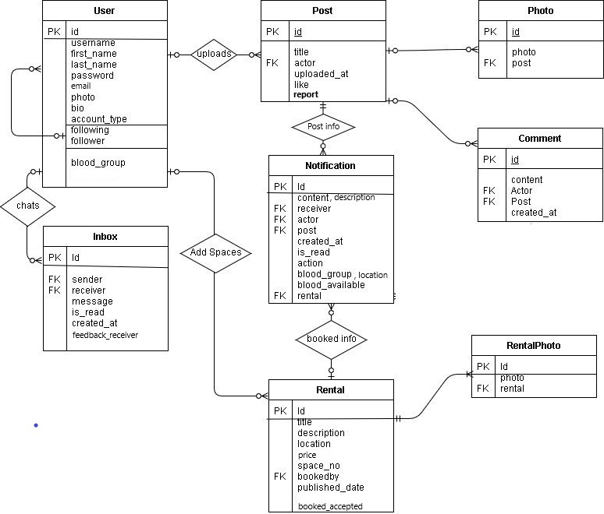

Figure 9 *: ER diagram*

### 3.3.2 Database Attributes, Constraints, keys

Below are the tables with the attributes used for the system which acts as properties for the actors or users of the system. The first column is the table name and the second column contains attributes name, datatypes, keys (table referencing keys, relationship denoting key between tables),default constraints used for the attributes and lastly the related name which is used while dealing in templates for n:m relationship and sometimes in views as a short form name which should be unique.

Table 10 : User Table Attributes and Constraints

|  |  |  |  |  |
| --- | --- | --- | --- | --- |
| **User** | | | | |
| ATTRIBUTES | DATATYPES | KEYS | DEFAULTS\  CONSTRAINTS | RELATED_NAME |
| id | NUMBER | pk | UNIQUE, Auto Increment |  |
| username | DEFAULT |  | UNIQUE |  |
| first_name | CharField(30) |  | NOT NULL |  |
| last_name | CharField(30) |  | NOT NULL |  |
| password | DEFAULT |  | NOT NULL |  |
| photo | ImageField() |  | Default='profile/avtar.jpg' |  |
| bio | CharField(100) |  |  |  |
| account_type | CharField(15) |  | Default = ‘Public’ |  |
| following | DEFAULT | n:m (User) |  | user_following |
| follower | DEFAULT | n:m (User) |  | user_follower |
| blood_group | CharField(255) |  |  |  |

Table 11 : Post Table Attributes and Constraints

|  |  |  |  |  |  |
| --- | --- | --- | --- | --- | --- |
| **Post** | | | | |  |
| ATTRIBUTES | DATATYPES | KEYS | DEFAULTS\  CONSTRAINTS | RELATED_NAME | |
| id | NUMBER | pk | UNIQUE, Auto Increment |  | |
| title | CharField(255) |  | NOT NULL |  | |
| actor | DEFAULT | fk |  |  | |
| uploaded_at | DateTimeField |  | auto_now_add=True |  | |
| like | DEFAULT | n:m(User) |  | like_posts | |
| report | DEFAULT | n:m(User) |  | report_posts | |

Table 12 : Photo Table Attributes and Constraints

|  |  |  |  |  |
| --- | --- | --- | --- | --- |
| **Photo** | | | | |
| ATTRIBUTES | DATATYPES | KEYS | DEFAULTS\  CONSTRAINTS | RELATED_NAME |
| id | NUMBER | pk | UNIQUE, Auto Increment |  |
| photo | ImageField |  |  |  |
| post | DEFAULT | fk |  | my_photo |

Table 13 : Comment Table Attributes and Constraints

|  |  |  |  |  |  |
| --- | --- | --- | --- | --- | --- |
| **Comment** | | | | |  |
| ATTRIBUTES | DATATYPES | KEYS | DEFAULTS\  CONSTRAINTS | RELATED_NAME |
| Id | NUMBER | pk | UNIQUE, Auto Increment |  |
| content | CharField(255) | pk | Blank=False |  |
| actor | DEFAULT | fk(User) |  |  |
| Post | DEFAULT | fk(Post) |  | my_comments |
| created_at | DateTimeField |  | auto_now_add=True |  |

Table 14 : Inbox Table Attributes and Constraints

|  |  |  |  |  |
| --- | --- | --- | --- | --- |
| **Inbox** | | | | |
| ATTRIBUTES | DATATYPES | KEYS | DEFAULTS\  CONSTRAINTS | RELATED_NAME |
| id | NUMBER | pk | UNIQUE, Auto Increment |  |
| sender | DEFAULT | fk(User) |  | sender |
| receiver | DEFAULT | fk(User) |  | receiver |
| feedback_receiver | DEFAULT | n:m(User) |  | feedback_receiver |
| message | CharField(1000) |  |  |  |
| image | ImageField() |  |  |  |
| is_read | BooleanField |  | default=False |  |
| created_at | DateTimeField |  | auto_now_add=true |  |
|  |  |  |  |  |

Table 15 : Notification Table Attributes and Constraints

|  |  |  |  |  |
| --- | --- | --- | --- | --- |
| **Notification** | | | | |
| ATTRIBUTES | DATATYPES | KEYS | DEFAULTS\  CONSTRAINTS | RELATED_NAME |
| id | NUMBER | pk | UNIQUE, Auto Increment |  |
| content | CharField(255) |  |  |  |
| receiver | DEFAULT | n:m(User) |  | notification_receiver |
| actor | DEFAULT | fk(User) |  | notification_actor |
| post | DEFAULT | fk(Post) | Default=’Neparu’ | my_notification |
| created_at | DateTimeField |  | Blank=True, Null=True |  |
| is_read | BooleanField |  | Default=False |  |
| action | CharField(255) |  | Blank=False |  |
| blood_group | CharField(255) |  | Blank=True |  |
| blood_available | CharField(255) |  |  | blood_responder |
| location | CharField(125) |  |  |  |
| rental | DEFAULT | fk(Rental) |  | My_rental |

Table 16 : Rental Table Attributes and Constraints

|  |  |  |  |  |
| --- | --- | --- | --- | --- |
| **Rental** | | | | |
| ATTRIBUTES | DATATYPES | KEYS | DEFAULTS\  CONSTRAINTS | RELATED_NAME |
| id | NUMBER | pk | UNIQUE, Auto Increment |  |
| title | CharField(15) |  |  |  |
| description | TextField(1000) |  |  |  |
| location | CharField(125) |  |  |  |
| actor | DEFAULT | fk(User) |  | rental_actor |
| price | IntegerField() |  |  |  |
| space_no | IntegerField |  |  |  |
| bookedby | DEFAULT | n:m(User) | Blank=True | bookedby |
| Book_accepted | DEFAULT | n:m(User) | Blank=True | Book_accepted |
| published_date | DateTimeField |  | auto_now_add=True |  |

Table 17: Rental Photo Table Attributes and Constraints

|  |  |  |  |  |
| --- | --- | --- | --- | --- |
| **Rental Photo** | | | | |
| ATTRIBUTES | DATATYPES | KEYS | DEFAULTS\  CONSTRAINTS | RELATED_NAME |
| id | NUMBER | pk | UNIQUE, Auto Increment |  |
| photo | ImageField |  |  |  |
| rental | NUMBER | fk(Rental) |  | rentalphoto |

## 3.4 Dynamic System Design

### 3.4.1 Events Charts

#### 3.4.1.1 External(Incoming Event) Chart

|  |  |
| --- | --- |
| External (Incoming) | Involved object types |
| Adding staff | USER_REGISTRATION_FORM,  ROLE, ADMIN |
| User signup | USER_REGISTRATION_FORM |
| Adding posts | POST_FORM, USER,POST_PHOTOS |
| Adding rental space | RENTAL_FORM, USER, RENTAL_PHOTOS |
| Message | MESSAGE_FORM, USER |
| Report or query | MESSAGE_FORM, USER, ADMIN |
| Book rental space | RENTAL, USER |
| Accept blood request | BLOOD_REQUEST, USER |
| Change password | PASSWORD_CHANGE_FORM, USER |
| Change information | USER_FORM, USER |

#### 3.4.1.2 Internal (Outgoing Event ) Chart

|  |  |
| --- | --- |
| Internal (Outgoing) | Involved object types |
| Admin send announcements | NOTIFICATION_FORM, USERS,ADMIN |
| Report post | POSTS, POSTS_PHOTOS, USERS |
| Comment on post | POST, NOTIFICATION, USER, COMMENT_FORM |
| Request for blood | BLOOD_FORM, USER, NOTIFICATION |
| Like post | USERS, NOTIFICATION, POST |
| Confirm space booking | RENTAL_FORM, USER, NOTIFICATION |
| Follow user | NOTIFICATION, USER |

### 3.4.1.3 Object Creation Charts

|  |  |
| --- | --- |
| Class | Creates instance of |
| STAFF | USER_SIGNUP_FORM, ADMIN |
| USER | SIGNUP_FORM |
| POSTS | POST_FORM, USER |
| COMMENTS | COMMENT_FORM, USER, POST |
| LIKES | USER, POST |
| FOLLOW | USER, FOLLOW_FORM |
| RENTAL SPACE | RENTAL_FORM, USER, RENTAL_PHOTOS |
| BLOOD REQEUST | BLOOD_REQUEST_FORM, USER |
| MESSAGE | INBOX_FORM, USER, ADMIN, STAFF |
| REPORT | POSTS,USER,ADMIN |

### 3.4.1.4 Admin System Scenario Charts

|  |  |  |  |
| --- | --- | --- | --- |
| **SCENARIOS** | **ADMIN_SUPPORT** | | **PART:** 1/5 |
| **COMMENT**  Scenario of sending notification to all the users | | **INDEXING**  Created by**:** Sudish Basnet | |
| **Login**  Start the system, navigate to login panel and enter credentials | | | |
| **Admin panel**  Dashboard automatically opens which contains notification data | | | |
| **Add Notification**  Above the notification table there is a hyperlink, add new notification click it | | | |
| **Notification Form**  Admin enters the details and redirected to dashboard | | | |
| **Event Display**  All the users are notified with the triggered by admin | | | |

|  |  |  |  |
| --- | --- | --- | --- |
| **SCENARIOS** | **ADMIN_SUPPORT** | | **PART: 2**/5 |
| **COMMENT**  Scenario of adding staff | | **INDEXING**  Created by**:** Sudish Basnet | |
| **Login**  Start the system, navigate to login panel and enter credentials  Admin can either enter to default Django admin panel | | | |
| **Admin panel**  On the navigation or list admin clicks on users | | | |
| **Add Users**  Admin clicks on add user on the top of panel and a form appear where admin fill up all the data with the selection of staff and submit | | | |
| **Event Display**  Admin is redirect to users’ panel and new user is added | | | |

|  |  |  |  |
| --- | --- | --- | --- |
| **SCENARIOS** | **ADMIN_SUPPORT** | | **PART: 3**/5 |
| **COMMENT**  Scenario of deleting reported posts | | **INDEXING**  Created by**:** Sudish Basnet | |
| **Login**  Start the system, navigate to login panel, and enter credentials | | | |
| **Admin panel**  Admin is redirected admin dashboard where admin navigates to posts | | | |
| **View Post**  Admins filters the table either reported post or non-reported, admin click reported post and select one post and view it | | | |
| **Delete Post**  Admin enters to the post page where admin verifies and on the top of right corner of post admin click and delete the post | | | |
| **Event Display**  The post fades out. | | | |

|  |  |  |  |
| --- | --- | --- | --- |
| **SCENARIOS** | **ADMIN_SUPPORT** | | **PART: 4**/5 |
| **COMMENT**  Scenario of responding feedback and queries | | **INDEXING**  Created by**:** Sudish Basnet | |
| **Login**  Start the system, navigate to login panel, and enter credentials | | | |
| **Admin panel**  Dashboard automatically opens, admin navigate to queries | | | |
| **View Queries**  On the queries panel there are list of queries or messages admin selects one | | | |
| **Respond query**  Admin enters to message form and replies the user. | | | |
| **Event Display**  Message added and user gets the message | | | |

|  |  |  |  |
| --- | --- | --- | --- |
| **SCENARIOS** | **ADMIN_SUPPORT** | | **PART: 5**/5 |
| **COMMENT**  Scenario of deleting user/staff | | **INDEXING**  Created by**:** Sudish Basnet | |
| **Login**  Start the system, navigate to login panel, and enter credentials | | | |
| **Admin panel**  Dashboard automatically opens, admin navigate to users | | | |
| **View users**  Admin is given list of users and option to filter either staff, user, or filter by name | | | |
| **Delete user**  Admin selects the user and click delete on its details which displays confirmation alert and admin confirms. | | | |
| **Event Display**  User data in the row fades out | | | |

### 3.4.1.5 Visitor System Scenario Charts

|  |  |  |  |
| --- | --- | --- | --- |
| **SCENARIOS** | **VISITOR_SUPPORT** | | **PART**: 1/3 |
| **COMMENT**  Scenario of requesting blood | | **INDEXING**  Created by: Sudish Basnet | |
| **Login**  Start the system, navigate to login panel, and enter credentials | | | |
| **User panel**  User panel opens, navigate to explore in navigation menu from left side of page | | | |
| **Display view**  Modal pop ups with the navigation where navigate to blood request | | | |
| **Add blood request**  Blood request form is open , enter the details as required where multiple requests at a time is restricted and submit the form if you are eligible. | | | |
| **Display view**  The submit button is changed with successfully asked and the modal closed. | | | |

|  |  |  |  |
| --- | --- | --- | --- |
| **SCENARIOS** | **VISITOR_SUPPORT** | | **PART**:2/3 |
| **COMMENT**  Scenario of adding post | | **INDEXING**  Created by: Sudish Basnet | |
| **Login**  Start the system, navigate to login panel, and enter credentials | | | |
| **User panel**  User panel opens, navigate to upload post in navigation menu from left side of page | | | |
| **Add Post**  Post uploading form opens, fill up the form with title and photos | | | |
| **Display booking record**  Information of booking in booking panel is updated with new entry. | | | |

|  |  |  |  |
| --- | --- | --- | --- |
| **SCENARIOS** | **VISITOR_SUPPORT** | | **PART**: 2/3 |
| **COMMENT**  Scenario of reporting post | | **INDEXING**  Created by: Sudish Basnet | |
| **Login**  Start the system, navigate to login panel, and enter credentials | | | |
| **User panel**  User panel opens, list of posts available in homepage, select any | | | |
| **Report post**  On the post at the right corner on the top of post there is button to report, click it | | | |
| **Event action**  If the report number exceeds the 10% of the number of followers that user have who uploaded the post then it will automatically delete otherwise, admin needs to view from his panel | | | |

### 3.4.2 Dynamic Diagrams

|  |
| --- |
| **Scenario: Rental Space** |
| 1. Open homepage of social media and login with user credentials. 2. User navigate to explore and navigate to rental service 3. Zookeeper navigate to watchlist in left hand side corner. 4. User click on add space 5. User input all the required data 6. User is redirected to main rental space panel after success 7. User1 search for space 8. User1 books the space 9. User accepts the booking 10. Notification is triggered to User1 11. User1 contact the 12. On event completion user’s logout, the session. |

|  |
| --- |
| **Scenario: Blood Request** |
| 1. Open homepage of social media and login with user credentials. 2. User navigate to explore and navigate to blood request 3. Blood request modal pop out and upper fill up the forms correctly 4. User can choose between individual request or for campaign 5. On confirmation blood is requested 6. Blood group given is checked and if not then all the users are notified otherwise matching users are notified via notification 7. User1 views the notification 8. User1 checks the availability and confirm 9. User checks the User1 details and contact 10. On completion of event user’s logout, the session |

# 4. System Interface Designs

In this section, the design for the system is given in details with the wireframes and mock-ups so that implementation for the system will be much more easier and in case of client requirement it will help viewers to know about the system that how it will look after completion.

## 4.1. Draft Interface Designs

### 4.1.1. Wireframes

Wireframes are designed to show the design, layout of the system before the implementation. In this section, the below wireframes are planned accordingly so that it can ease during development where the content part will be changed but not the navigation where navigation changes with the privileges of users.

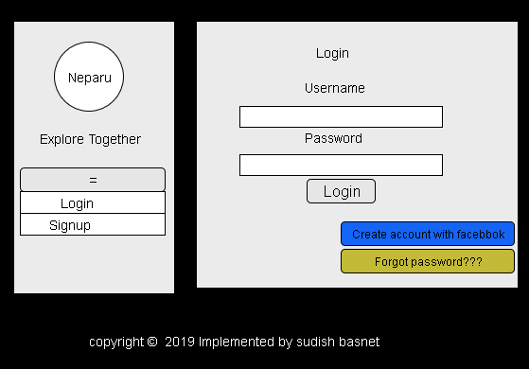

Figure 10: Login Wireframe

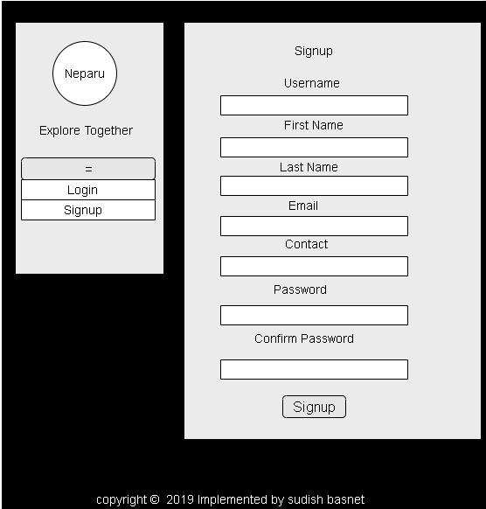

Figure 11: Signup Wireframe

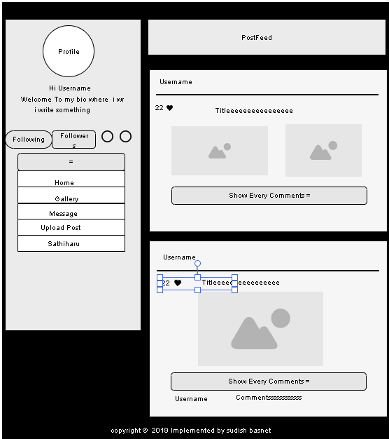

Figure 12: Post feed Wireframe

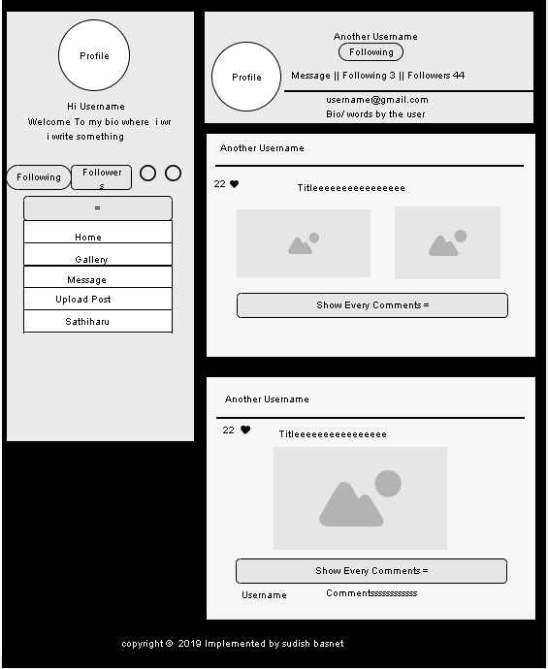

Figure 12 : User page Wireframe

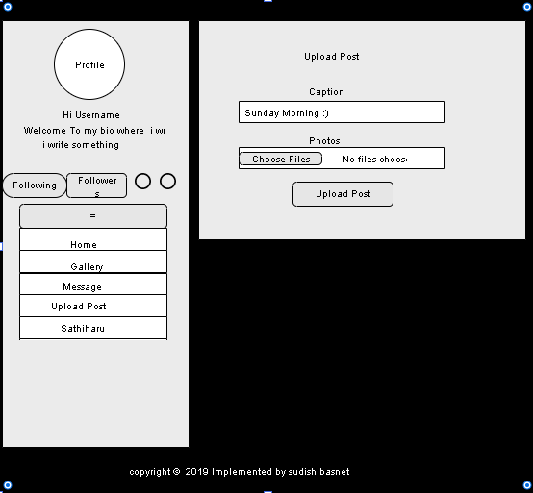

Figure 13 : Upload Post Wireframe

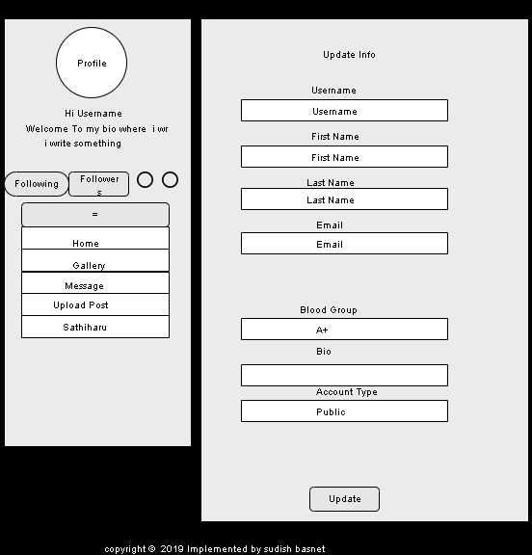

Figure 14 : Info update Wireframe

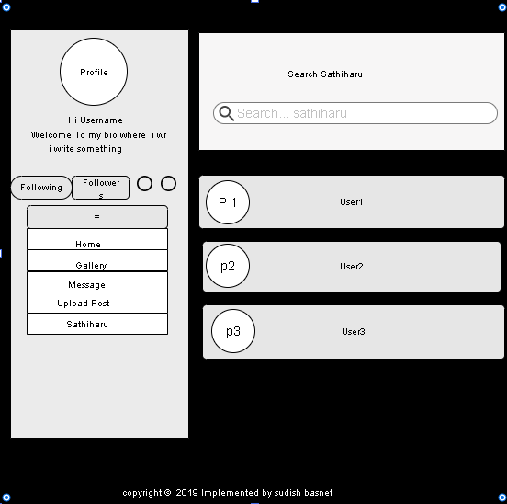

Figure 15 : Search friend(Sathiharu) Wireframe

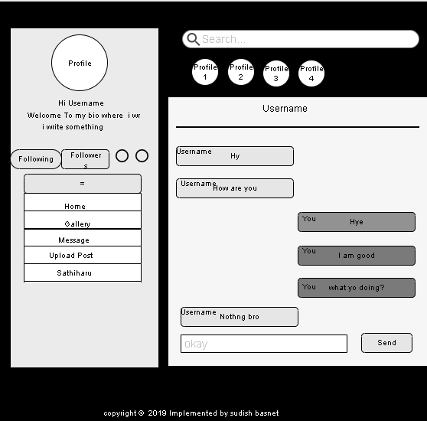

Figure 16 : Message Box Wireframe

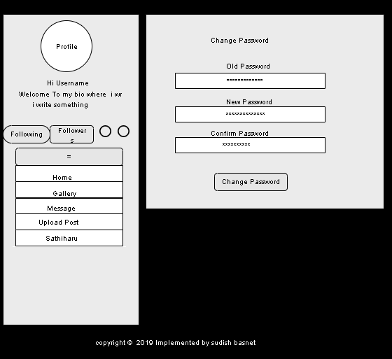

Figure 17 : Change Password Wireframe

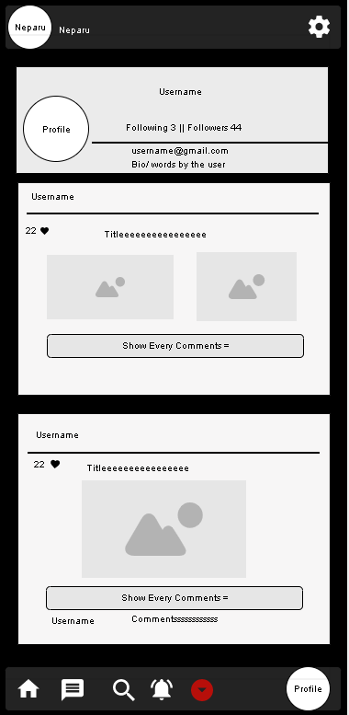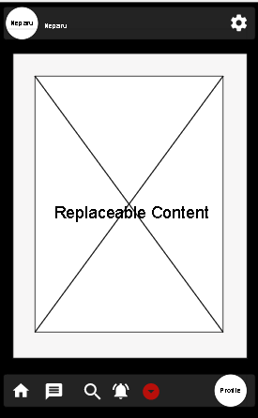

Figure 18 : Mobile customization Wireframe

Figure 19 : Mobile customized user page Wireframe

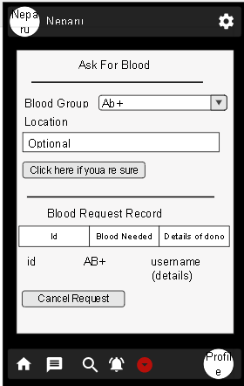

Figure 20 : Mobile Customized Blood Request Wireframe

### 4.1.2. Mock-ups

After the completion of wireframes, for the implementation of system, clean and colourful version of wireframe is designed which is called as mock-ups. Below are the figures which shows more clearly about how the system going to be.

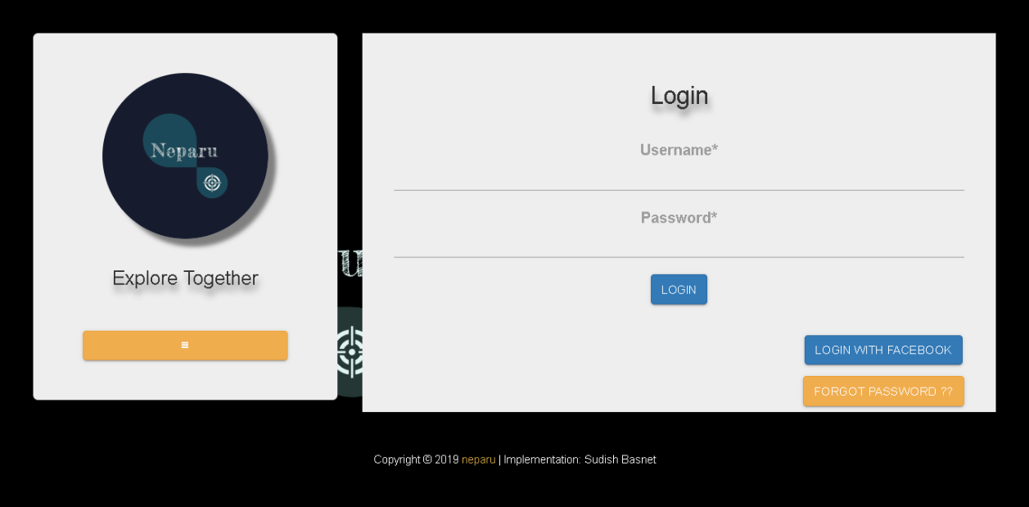

Figure 21: Login Mock-up

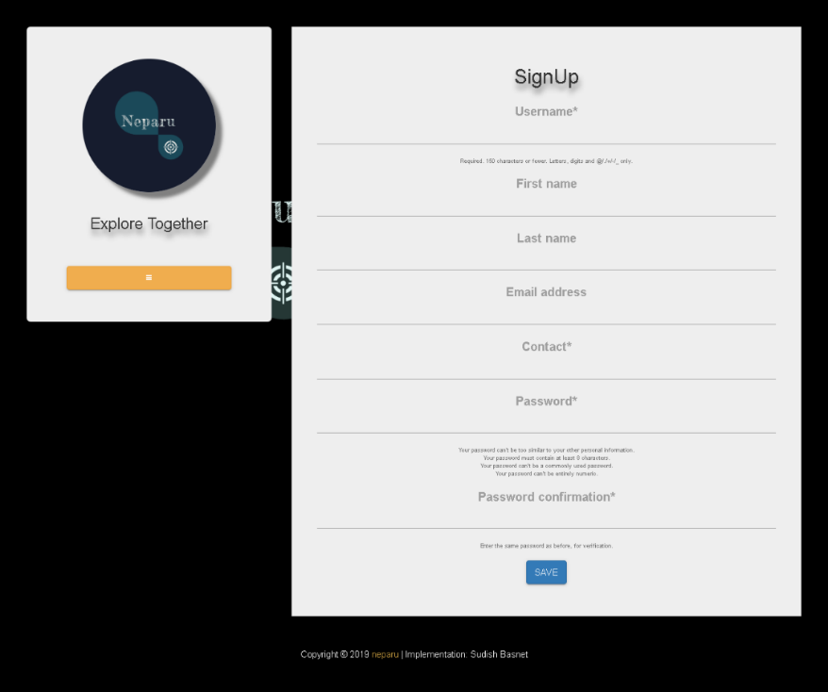

Figure 22 : Signup Mock-up

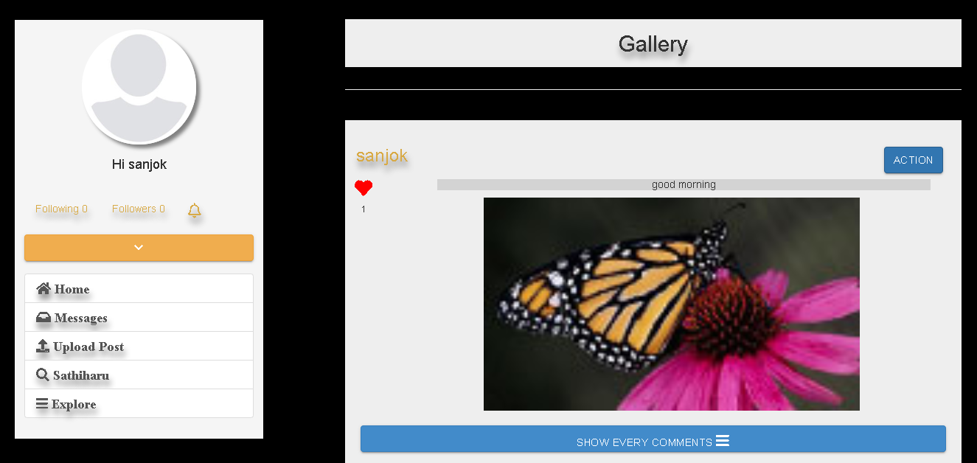

Figure 23 : Navigation bar mock-up

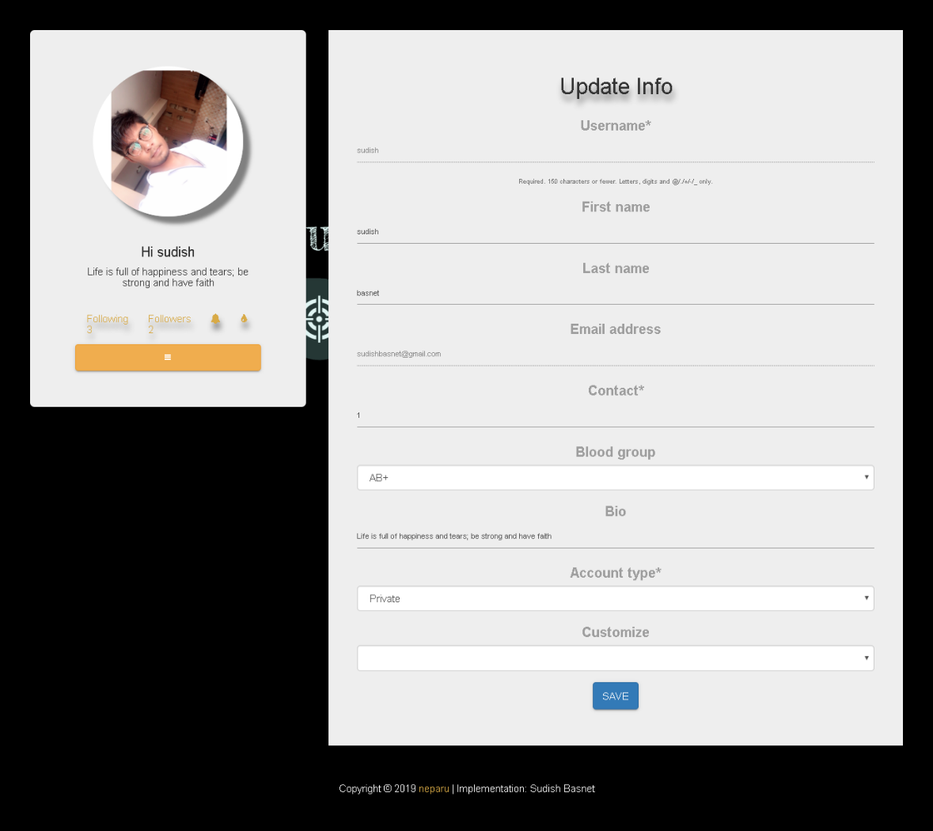

Figure 24 : Info Update Mock-up



Figure 25 : Post feed , Gallery Mock-up

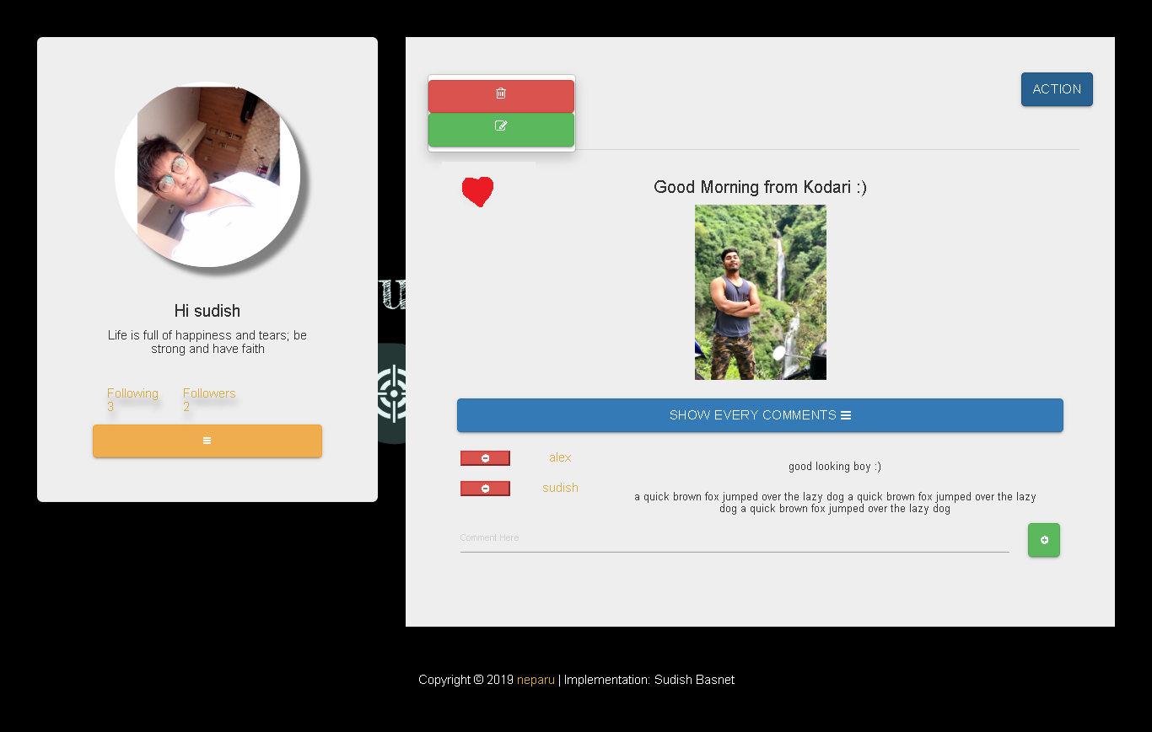

Figure 26 : Post details Mock-up

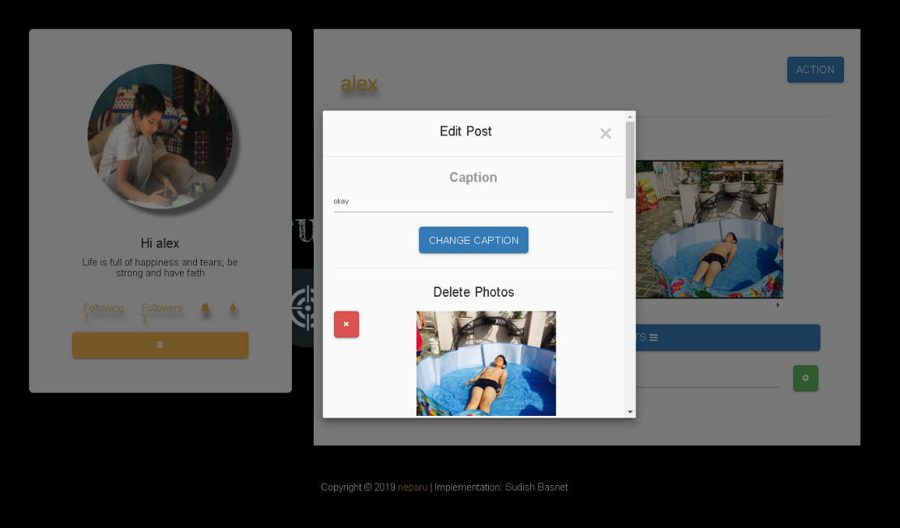

Figure 27 : Post edit Mock-up

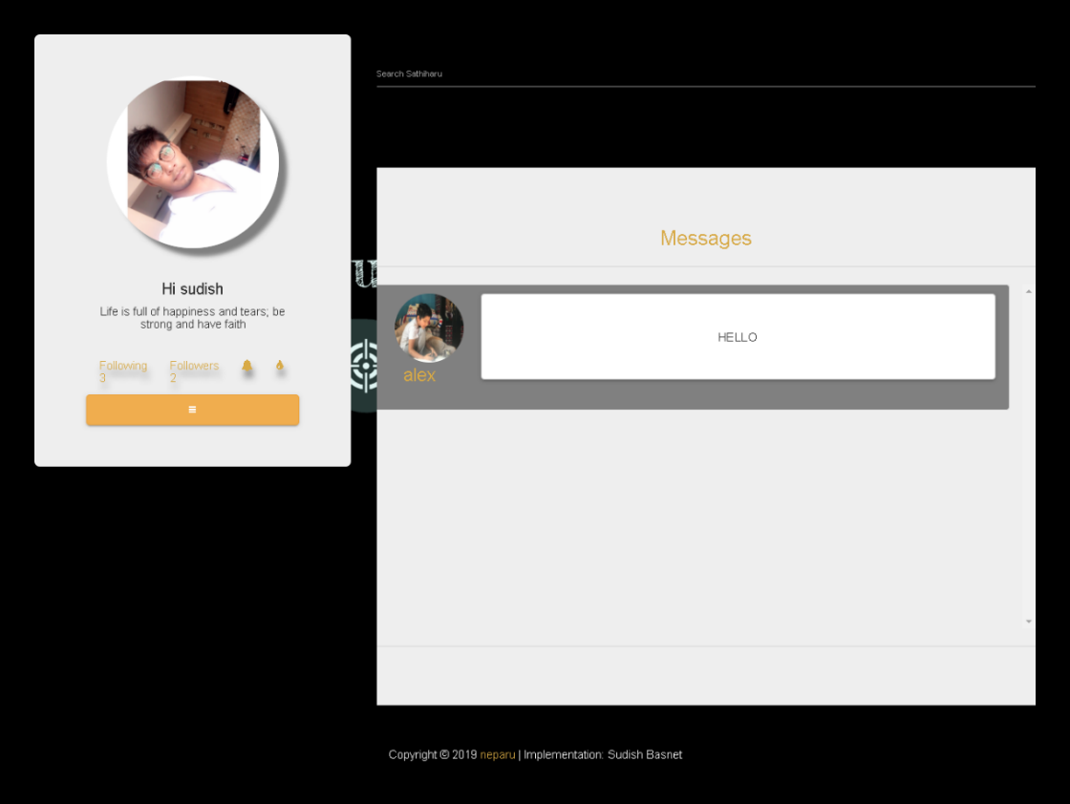

Figure 28 : Inbox Mock-up

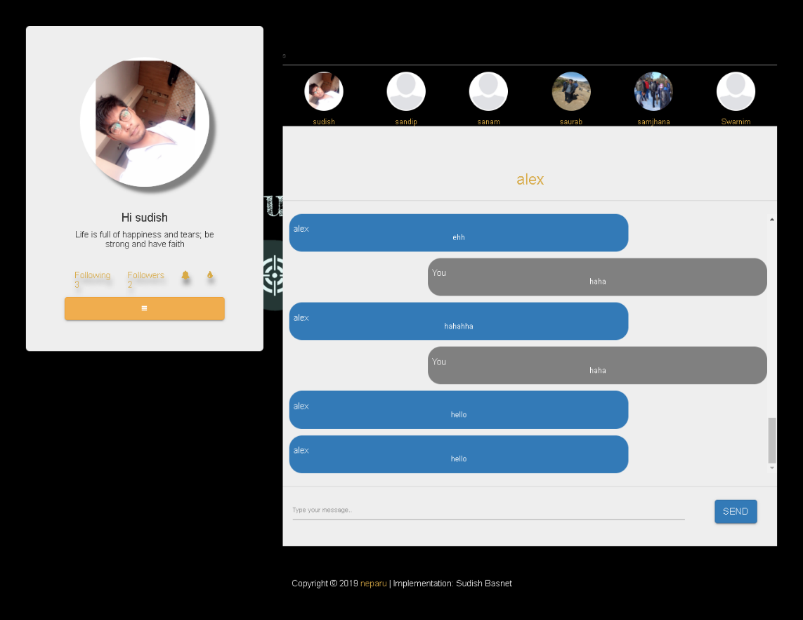

Figure 29 : Message Box Mock-up

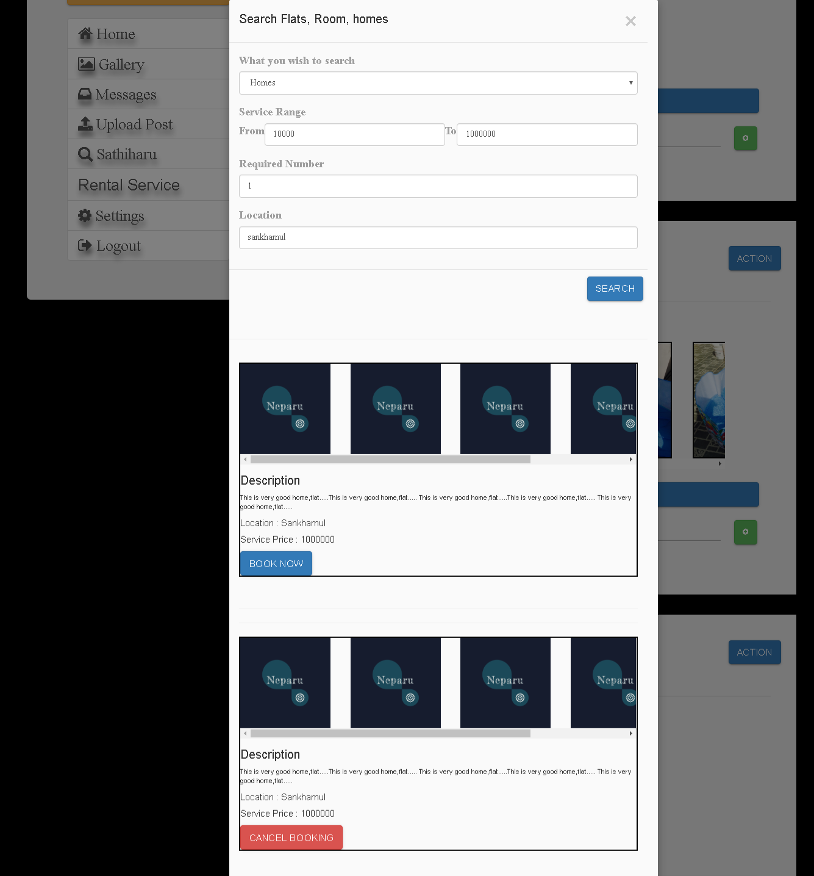

Figure 30 : Rental Service Mock-up

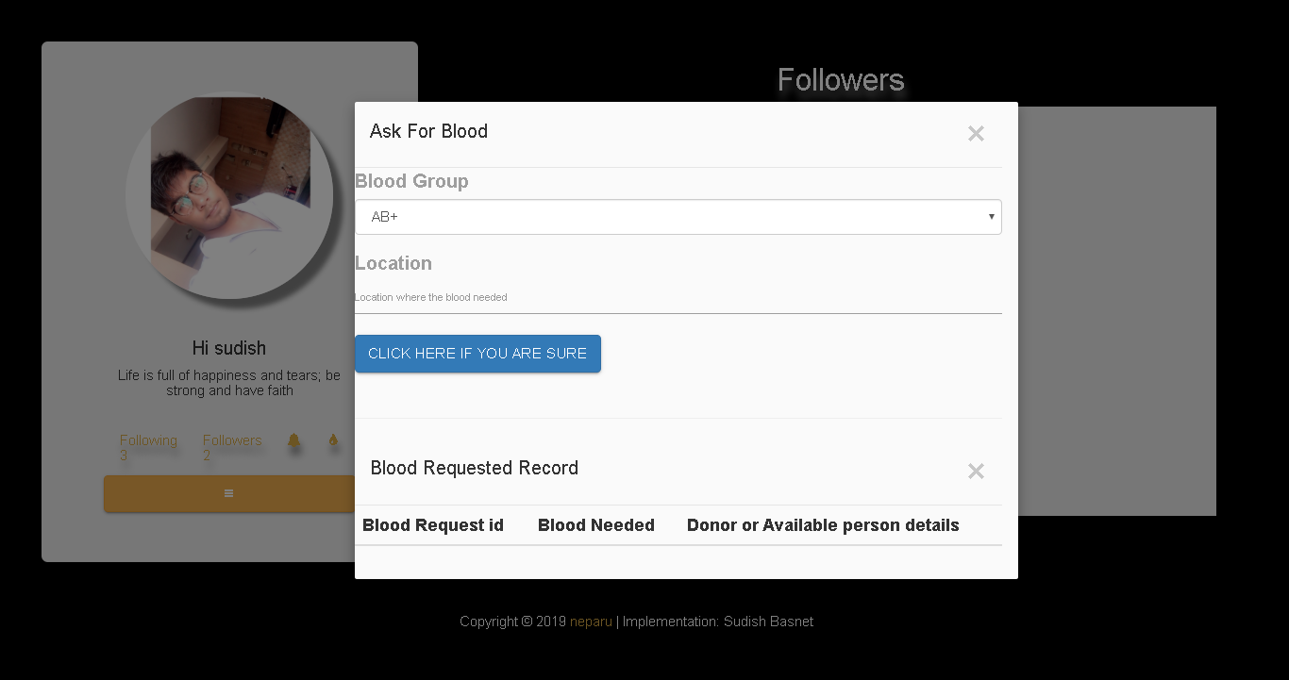

Figure 31 : Blood Request Mock-up

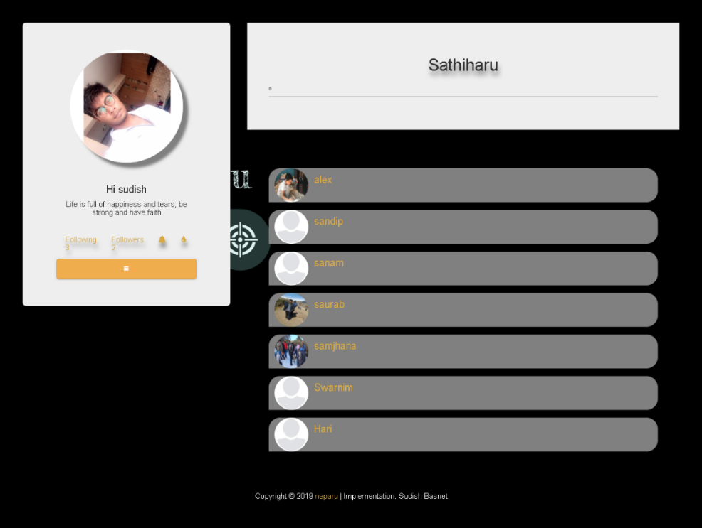

Figure 32 : Search Friend ( Sathiharu) Mock-up

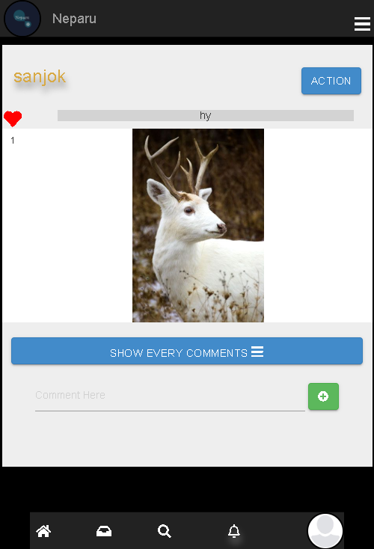

Figure 33 : Mobile Customized User Page Mock-up

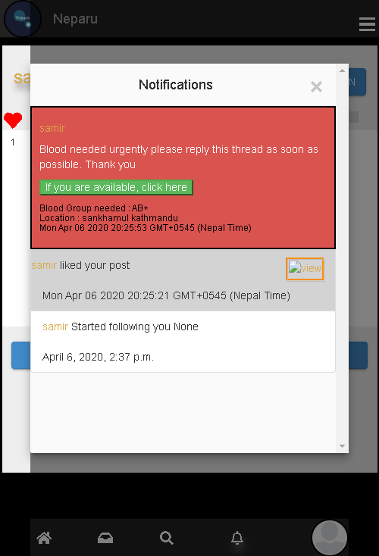

Figure 34 : Mobile Customized Notification Mock-up

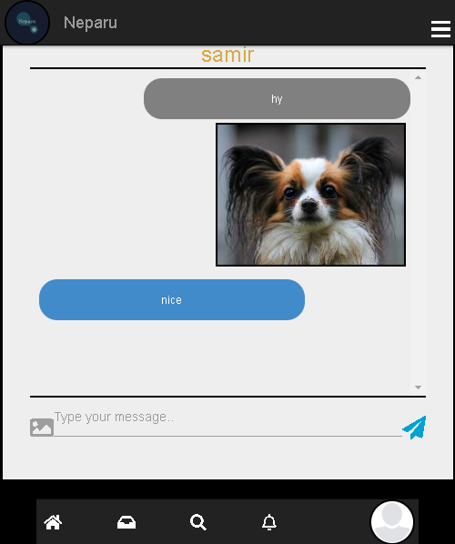

Figure 35 : Mobile Customized Message Box Mock-up

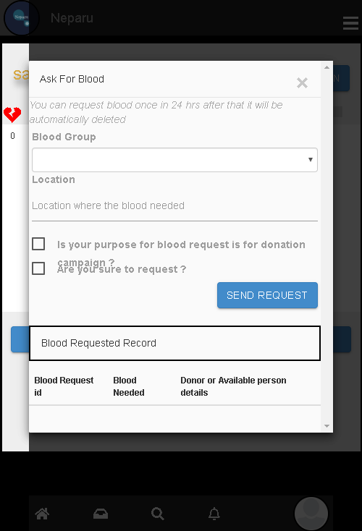

Figure 36 : Mobile app blood request Mock-up

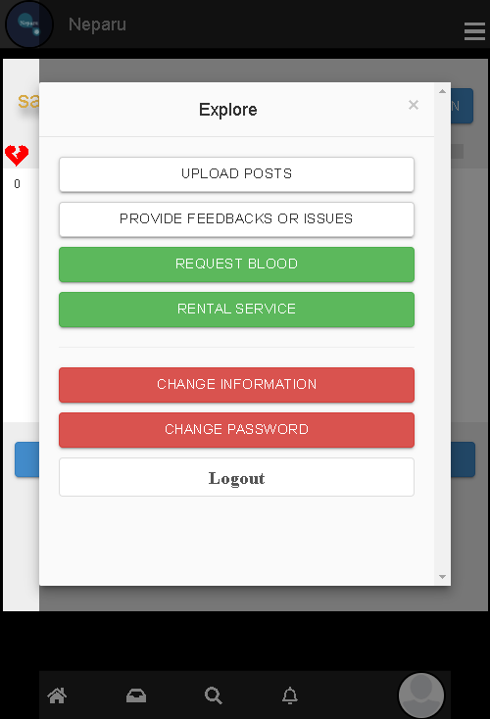

Figure 37 : Mobile customized explore mock-up

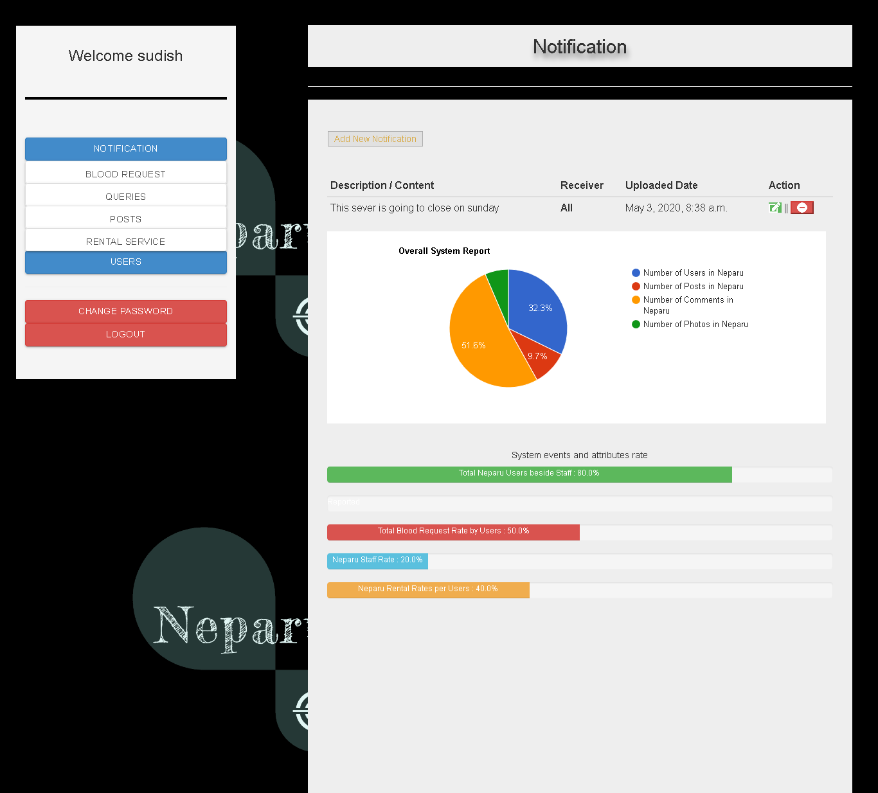

Figure 38 : Admin onboard panel mock-up

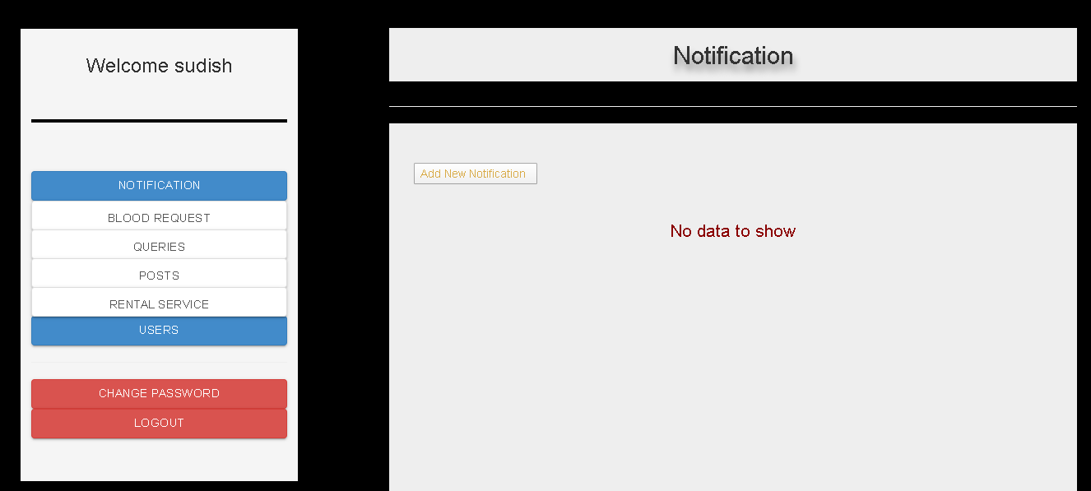

Figure 39 : Admin page Mock-up

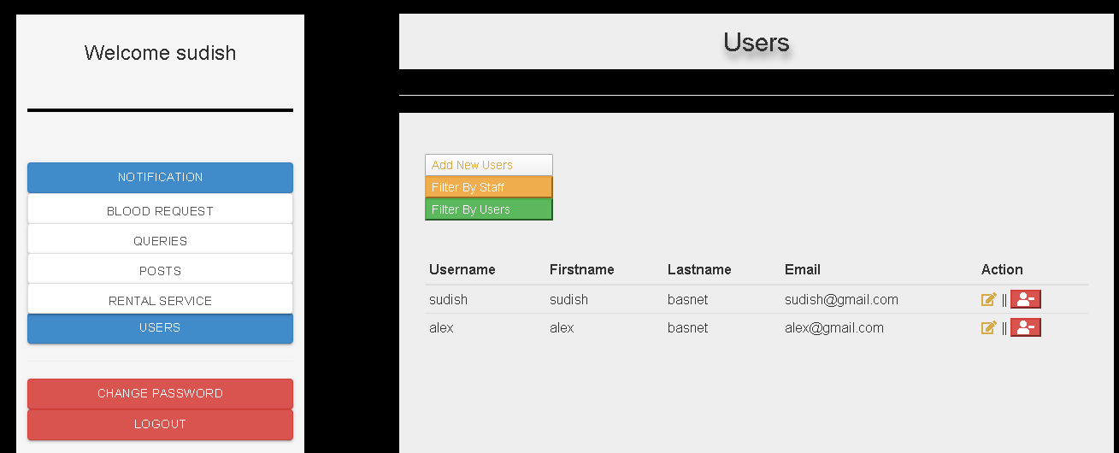

Figure 40 : Admin page layout for user panel mock-up

### 4.1.3. Event Diagram

Some flowcharts to show the system activity event to know how the actual system works are listed below where starting with the system opening, it processes through several levels like document, processing, input and conditions . The flowchart is designed with simple and normal words so that viewers can get insight view of system workflow.

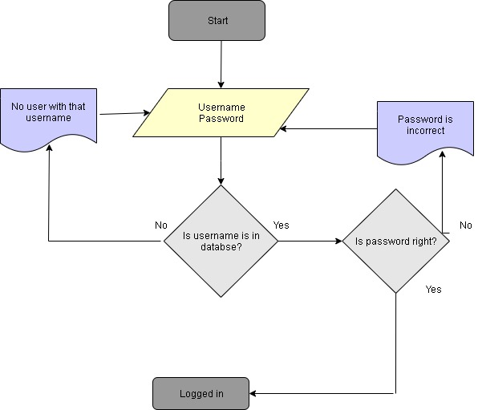

Flowchart 2 : Flowchart of Login Process

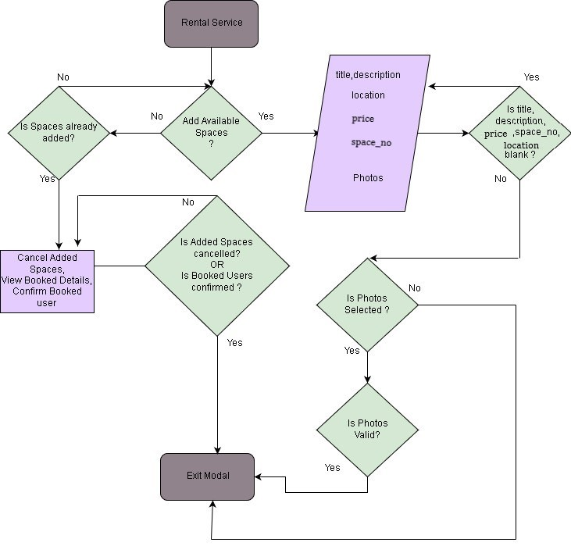

Flowchart 3 : Rental Service Flow Chart

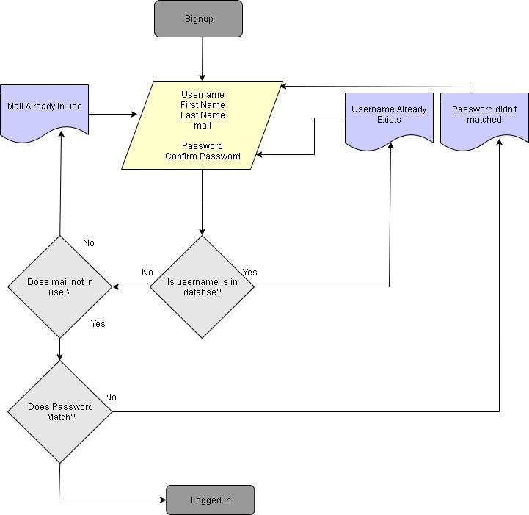

Flowchart 4 : Flowchart of Signup process

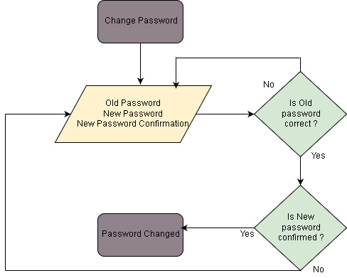

Flowchart 5 : Change Password Flowchart

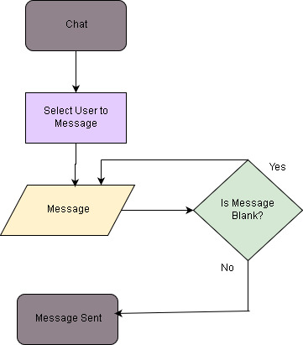

Flowchart 6 : Chat Flowchart

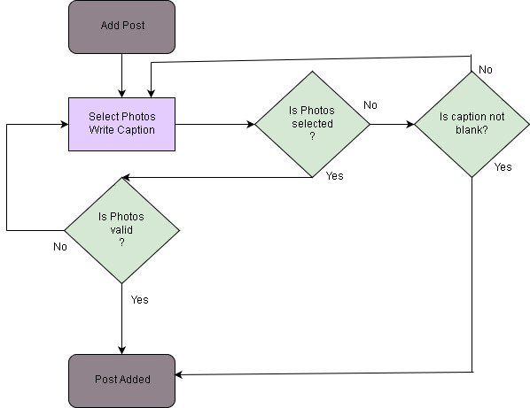

Flowchart 7 : Add Post Flowchart

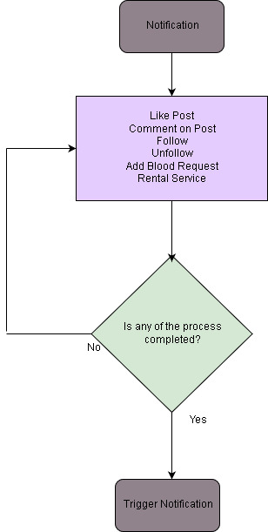

Flowchart 8 : Notification Trigger Flowchart

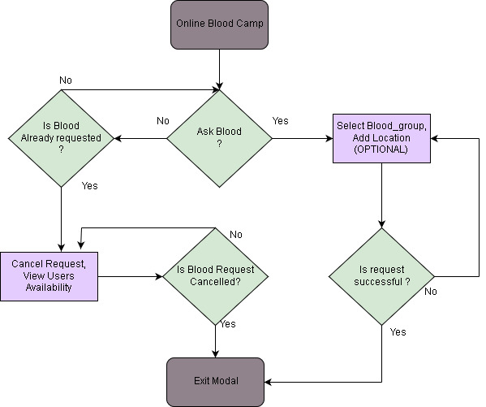

Flowchart 9 : System Online Blood Bank Flowchart

### 4.1.3. Navigation Diagram

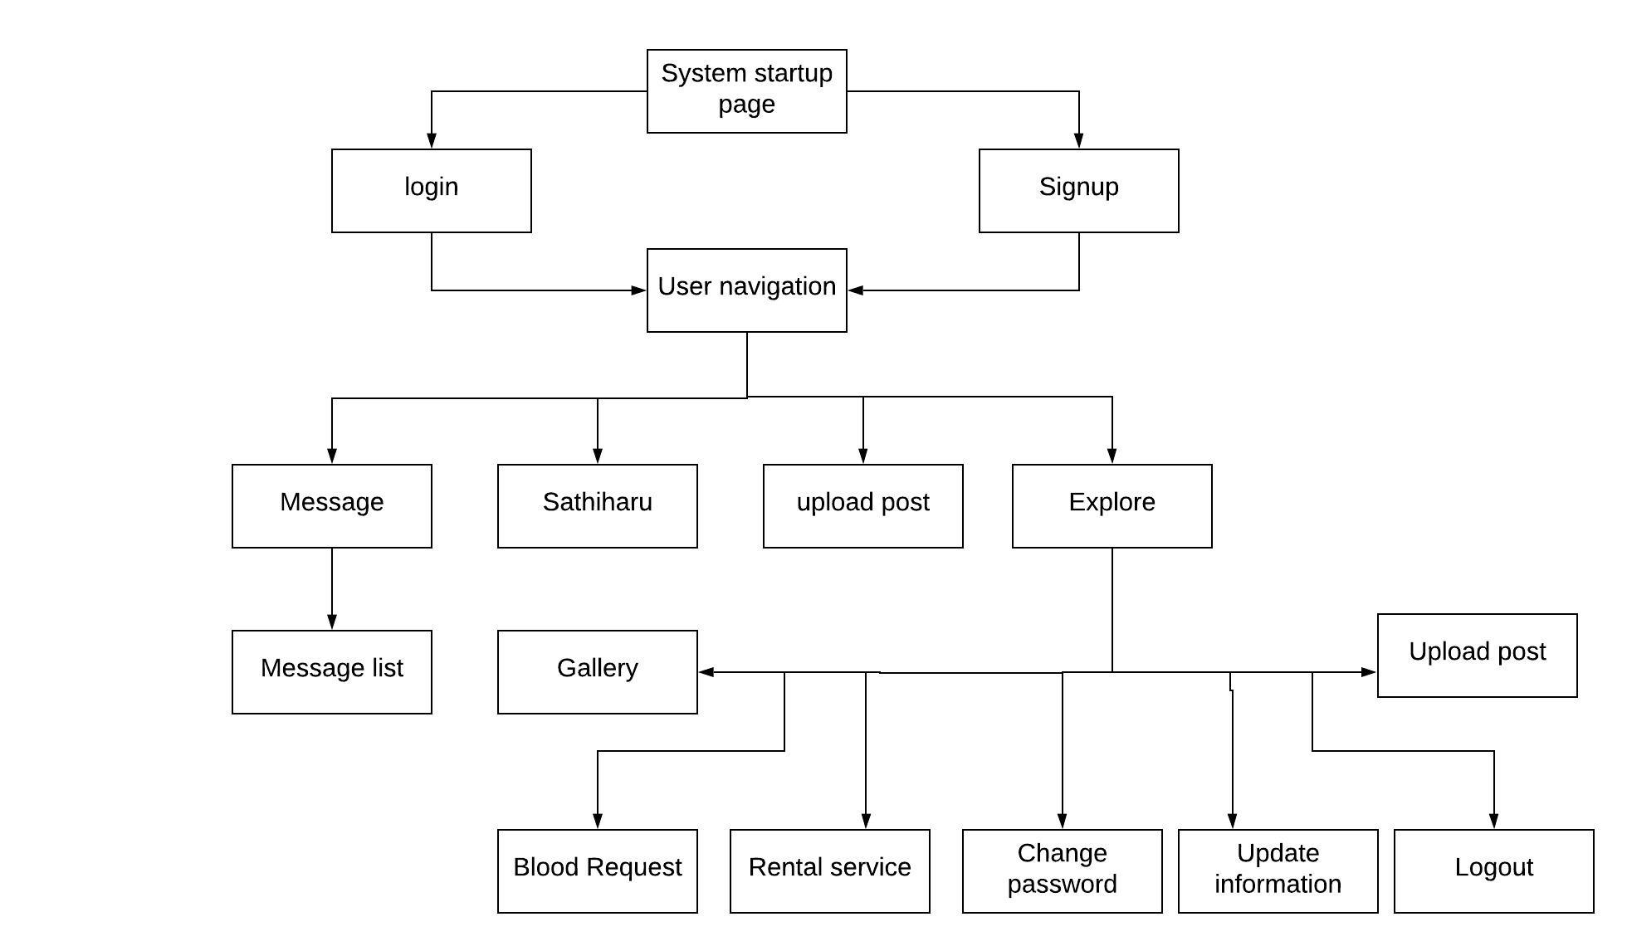

Flowchart 10 : User navigation panel

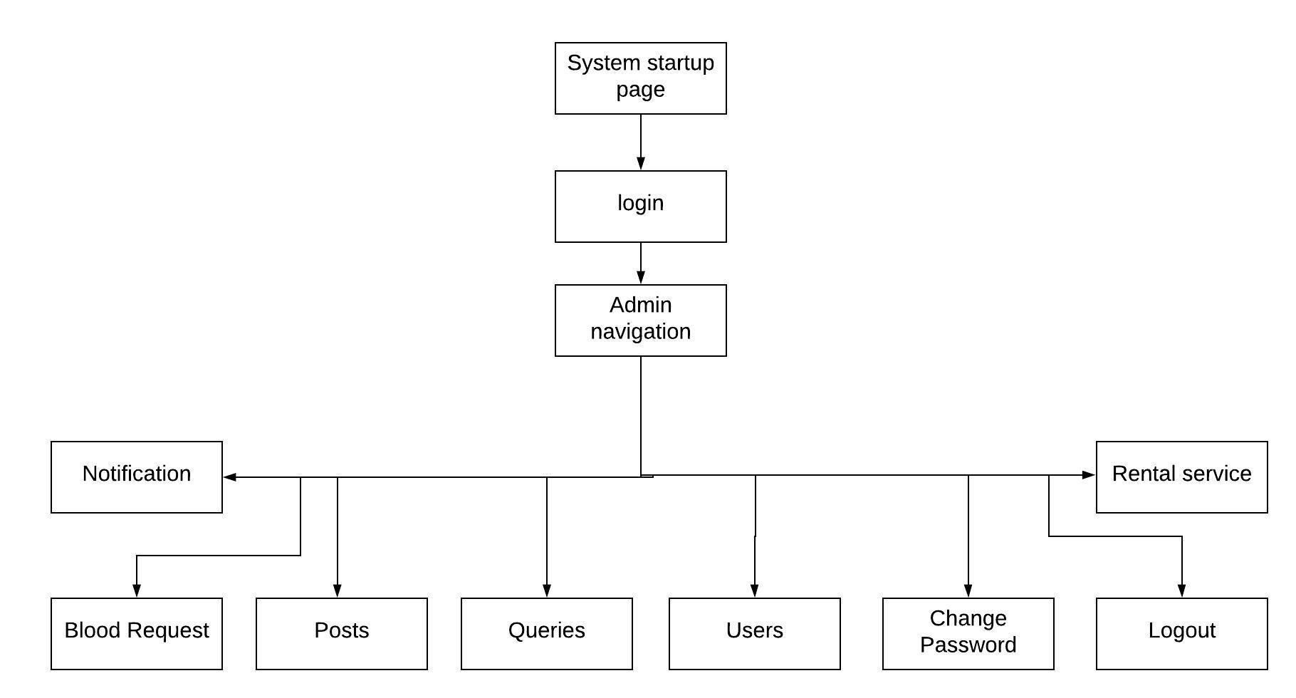

Flowchart 11 : Admin navigation panel

# 5. System Build and Technical Notes

After the completion of requirement engineering and system analysis and design, now system can be build following those ideas. In this section some of the technical notes will be figured out which have been used to implement system till now. To access the system implemented , individual must open the folder and in the root directory there is README.md file which will guide.

In the given figure below, it is the main directory for the system where it consists of folder and files like model, forms, views, URLs, Static files migrations, tests, serializers, admin, templates, social media. In the social media folder, it is for system purpose with settings.py and the main URLs section for the app. In the folder neparu where several files and folders are associated belongs to app. The pycache and migrations is for the database management , static for system design operations files like CSS, JS , system images. The templates folder consist of html files which will be rendered by views.py with several functions on the call of URLs file which gives the specific path for views and in views it is controller for models.py which is the class for database structure and the admin.py is for the purpose of displaying the database classes in the admin section of default Django which can be assess with the system URL and then / admin. The forms.py contains the forms for all the models so that it will be easier to setup in templates by just calling.

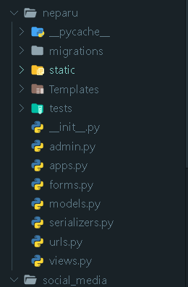

1. Connecting Database with SQLite3 engine in Django where the path for database mail management file is set at base directory.

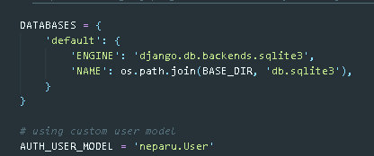

Figure 41 : Database engine connection

1. Providing location for static files and setting up bootstrap to use . The redirect URL for login and logout is also provided and the URL for static files which can be accessed by templates in app directory with the load static command. The media URL below is for the files that users upload will be save there which is located at the base directory . The Heroku syntax is not important for this as because it for system deployment , for now system will be run on local server.

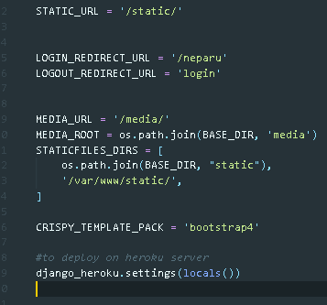

Figure 42 : Setting up static files

1. URL pattern for connecting URLs with the views function or classes where the path should be imported on top of the list. The first position in the path is for URL location and second with views is for calling functions so that it will render templates.

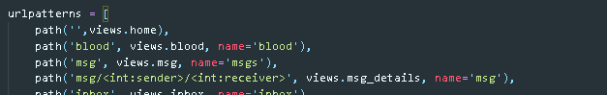

Figure 43 URL patterns

1. Abstracting Django default user table to customize with the system properties where the AbstractUser in the class is to abstract data from existing table and inside the class the attributes will be set in left position. The upload_to will be used to upload the uploaded file to destination folder where for photo default is set as avtar.jpg. The following attributes below is for adding users where this is the cool feature of Django with many to many field where a single attribute will act as list .

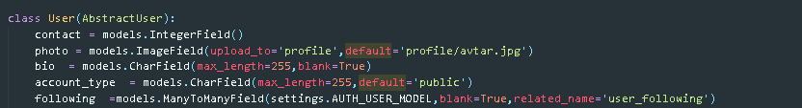

Figure 44 : Abstracting default user

1. Creating new model in the database apart from default database model for post where the function __str__ is for knowing the class or simply identifying which can be used as pk sometimes.

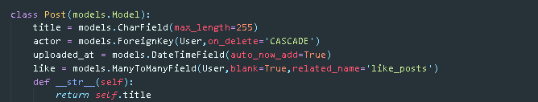

Figure 45 : Creating new Model

1. Creating form for the template in accordance with the model created where the meta class will include the model fields which need to be present and the widget contains the functions for the forms like attributes, ids, class. Below is the case for user creation is used with the by default class but in case of user creation class like post it should include models.Model instead UserCreationForm. The unique_together can be used to make the attribute unique which will check the model data and warn the user accordingly.

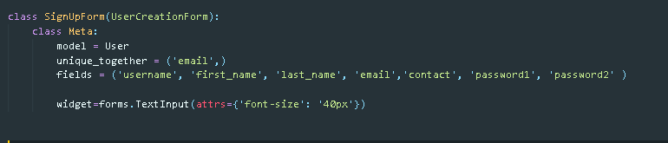

Figure 46 : Creating new Form

1. Script to call the function after seconds for the implementation of notification and chatting events where the notification_receiver is default set to the id of user in the session. Whenever the id I greater than 0 which means whenever user logins the receive notification function is called every 2 second which can be adjusted by us .

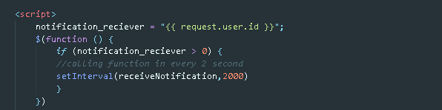

Figure 47 : Recall function with script

1. Creating serializer with the model created for the data transmission in text-based like json in this system from the Django model. This type of serializer class for this system is used for message and notification with the models and attributes as required which will be called and used during the call of java script file with the function related and it will redirect to views function if the function like receive function from above figure is called.

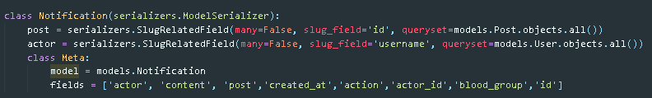

Figure 48 : Serializer

1. Creating new function and querying data from model and using serializer to set data and send through the json response which will help to implement as ajax. The is the same function in views file which is called by the java script function during each call and then it loads serializer for data transfer.

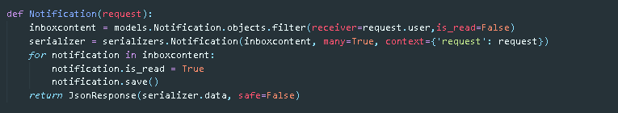

Figure 49 : Function with serializer and JsonResponse

1. Creating a function call “receiveNotification” to receive notification which is called by the above recalling function every second. The second line of the function with get method helps to get data from URL and received data will then looped to prepend in the tag somewhere in templates. The same technique is used for Inbox or chatting too.

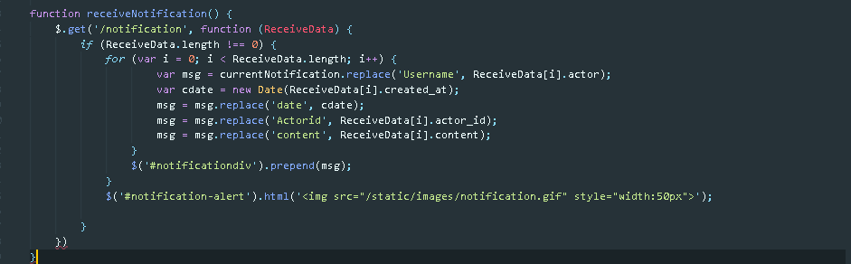

Figure 50 : Receive Notification with JS

1. Using ajax to like post with on click event using tag id . The request to send data is set POST and URL for the location is “/neparu/like” where data is sent and with the success it sends json data which is then processed according as below with success function. Same idea is followed by every possible event like comment , search etc.

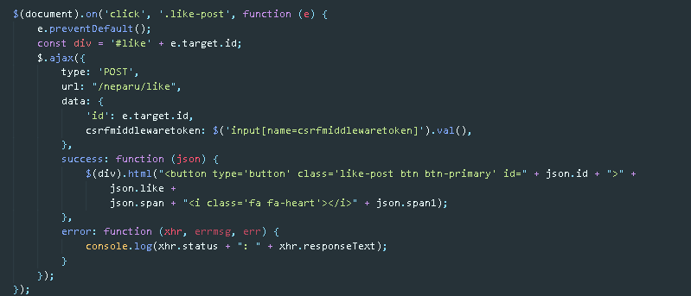

Figure 51 : Ajax with JS for like

1. Including backend authentication for existing social so that it will be easier to login or signup . Facebook app id and secret key is given so that it will redirect to Facebook and user must accept.

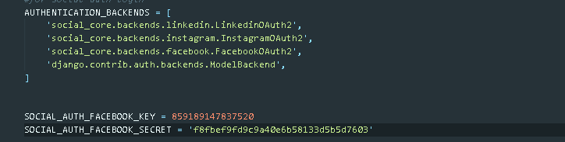

1. Adding navigation to the system with the user authentication condition and if user is using it from either mobile or pc. The same tricks are used mostly throughout the system.

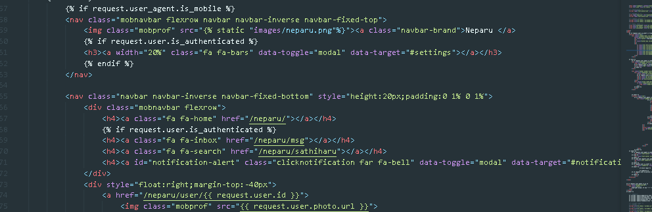

1. Using block in index template so that the whole template can be reuse throughout the system by extending the block in other pages where only the content inside the block will be change others remain same.

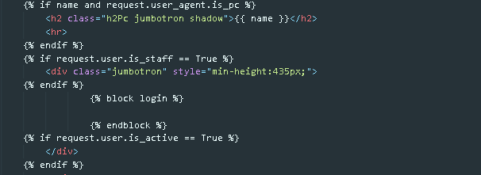

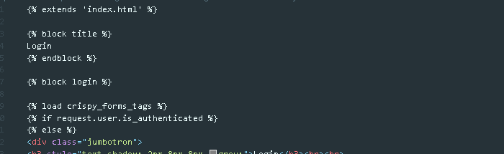

1. Including all the installed app and modules or frameworks that are going to be used. Neparu in the installed app is the app name , crispy forms is for bootstrap forms, Django extensions and dajngo_user_agents is for detecting device from using user logins, social Django is for authentication of social media for login and signup and coverage for test report for which selecting which functions will be tested.

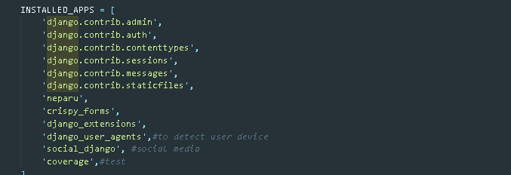

1. Below is the template file for searching user which is same for all the search cases in the system . The input tag is used for the purpose on key up on which the function is called.

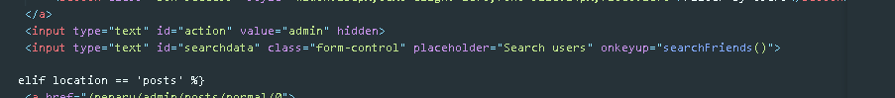

After the function is called, it all about the system internal processes. The search friend function contains the data about the URL where it should redirect , display time processing and the technique like either to fadeout the data or just change the data which is all adjustable by the programmer according to the need of system performance. Inside the ajax call, the done function contains the system workflow about what should be change where div with id querydata is taken for this event. The constraint with req_param is the data values that will be send through the ajax to the views.

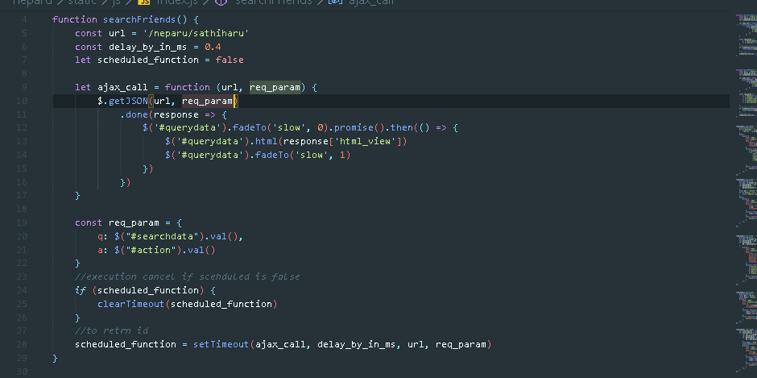

Below is the sathiharu function in the views file which is use for user searching in the system either it is for message users, admin user or normal user searching. Inside the function conditional statement for ajax request is don upon which sub conditional statement are checked according to system ajax request with the comparison of GET request data and then after filtering data with the GET data for model, template is render accordingly with the context provided depending upon request which information is responded by json.

# 6. Test Techniques

Real time testing is done with some data inputs to the system events during the implementation which were effective and shown at the evaluation. Below are the unit and black box testing:

## 6.1 Real Time Testing

During the development, testing the functionalities were done where many of the errors were due to syntax as well as path so the path was declared properly after few errors on same events. Sometime missing package were causing error and were sort out after knowing the required packages , which are now written in requirements.txt in the root directory of system. Overall, all the development progress is tested properly to find out I there any errors like syntax or models.

## 6.2 Unit Testing

The initial level of testing in which all the independent and small units are tested individually is called as unit testing. Below is the first figure coverage report through which it justifies all the functionalities or code will be tested out. After coverage report, all the testing functionalities or code is shown with results.

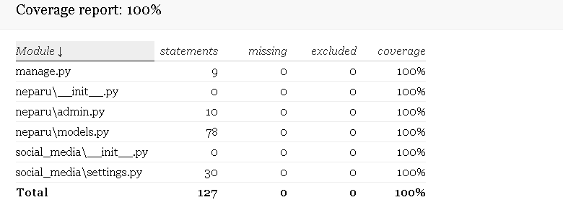

Forms testing :

Signup form testing:

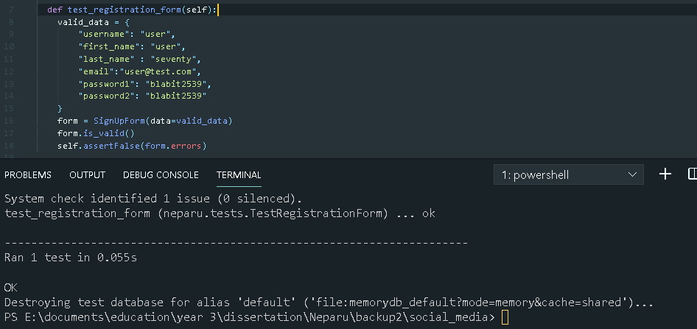

Testing with blank first name:

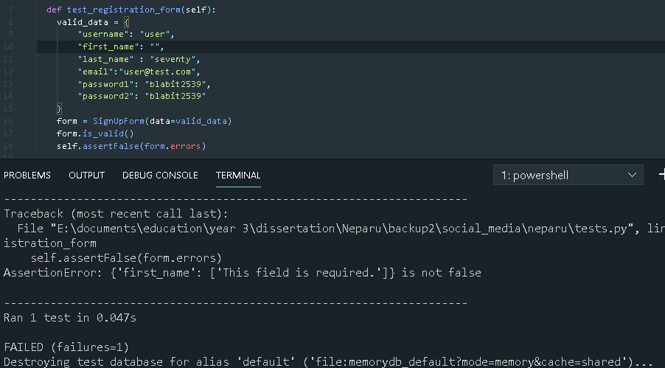

All the columns are also tested with null values which will be shown at last after completion with each function.

Below is the test for rental service with valid data as well as invalid which shows 2 tested and 1 is ok and another is failure.

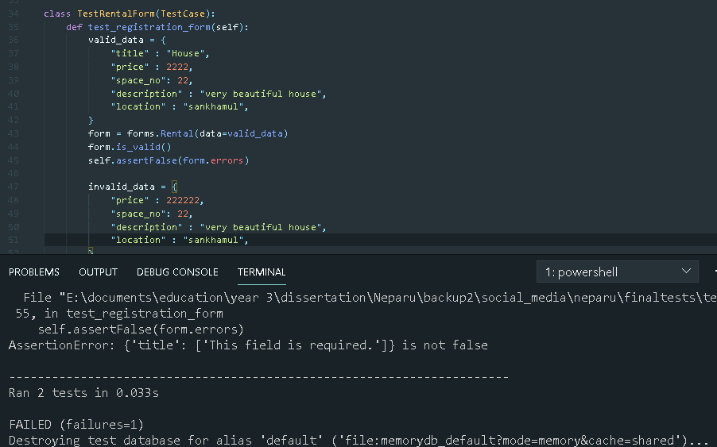

Similarly, for signup form update we can follow up same step

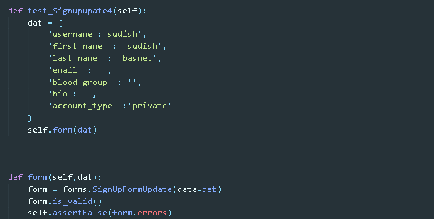

Overall, with the testing of 3 main forms with 16 tests it shows 13 error and failure which is same for this kind of condition due to required field. Hence 3 of the forms data is correct that means the unit testing for forms is successful.

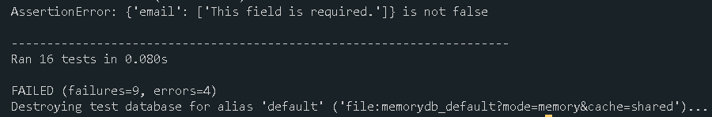

Models Testing:

All the process for models testing is same, there may be difference of attributes. Below is the testing for model’s inbox and comment.

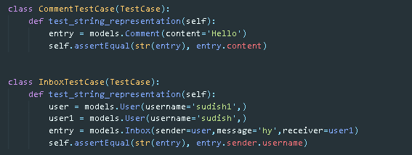

Overall testing result of main 6 models with ok test result is below:

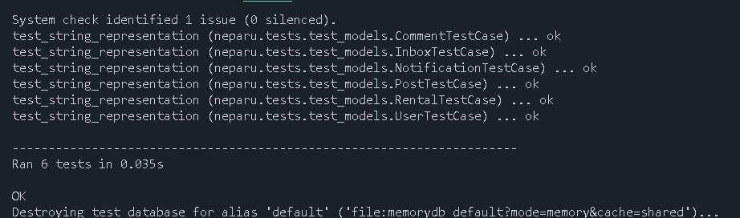

Unit test done is shown in below for overall look about the internal functions of the web app with failure as the invalid data tested and ok with valid data.

|  |  |  |  |
| --- | --- | --- | --- |
| Tested unit | Expected result | Actual Result | Remarks |
| forms | 3 ok 13 failure | 16 tested  3ok  13 failure | Good to go |
| models | 6 tested  6 oks | 6 tests ok | Good to go |
| views | 15 tested  15 oks | 15 oks | Good to go |
| Overall | 34 tested  24 oks | 34 tested  24 oks | Good to go |

## 6.3 Black box Testing

Though unit testing is done but it is not the case because some time errors may occur due to external issues rather than small units’ error. Black box testing is the testing procedure for testing functionality of system externally without looking at internal structures. Below are the tables showing the result of black box testing done for the system.

In the table cases are the condition when user enter some valid data or invalid where T means correct data and F means wrong data . According to test cases expected result and actual result is carried out with online system.

|  |  |  |
| --- | --- | --- |
| **Action** | **Expected Result** | **Actual Result** |
| **Login**   * Case1   Username = T  Password = T   * Case2   Username = T  Password = F   * Case3   Username = F  Password = F   * Case4   Username = F  Password = T | * Enter to home page * Wrong password * Username and password wrong * Password wrong | * Enter to home page * Error message : Please enter correct username and password * Error message : Please enter correct username and password * Error message : Please enter correct username and password |
| **Sending Notification by Admin**   * Case1   Description = T   * Case2   Description = F | * Send Notification * Error message | * Notification Added and redirect to notification panel * Error message : Please fill out this field. |
| **Signup**   * Case1   Username = T  First name = T  Last name = T  Mail =T  Password = T  Confirmation Password = T   * Case2   Username = F  First name = T  Last name = T  Mail =T  Password = T  Confirmation Password = T   * Case3   Username = T  First name = F  Last name = T  Mail =T  Password = T  Confirmation Password = T   * Case4   Username = T  First name = T  Last name = F  Mail =T  Password = T  Confirmation Password = T   * Case5   Username = T  First name = T  Last name = T  Mail = F  Password = T  Confirmation Password = T   * Case4   Username = T  First name = T  Last name = T  Mail =T  Password = F  Confirmation Password = T | * Enter to home page * Username exists * Invalid field * Invalid field * Email exits, Incorrect email format * Password mismatch, common password | * Enter to home page * Error message : A user with that username already exists. * Error message : Please fill out this field. * Error message : Please fill out this field. * Error message : User with this email already exits , Incorrect mil format * Error message : The two fields did not match , the password you used is too common |
| **Change Password**   * Case1   Old Password = T  New Password = T  Confirm Password = T   * Case2   Old Password = F  New Password = T  Confirm Password = T   * Case3   Old Password = T  New Password = T  Confirm Password = F | * Password changed * Wrong old password * Password mismatch, common password | * Enter to home page * Your old password was entered incorrectly. Please enter it again * Error message : The two fields didn’t match , the password you used is too common |
| **Upload Post**   * Case1   Title = T  Photos = T   * Case2   Title = T  Photos = F   * Case3   Title = F  Photos = T | * Gallery page opens * Invalid title * File absent | * Redirect to gallery page * Error message : Please fill this field * Error message : Please select a file |
| **Request Blood individually**   * Case1   Blood Group = T  Location = T  Confirmation = T   * Case2   Blood Group = T  Location = F  Confirmation = T   * Case3   Blood Group = T  Location = T  Confirmation = F  **Blood Request for campaign**  **(**For this case blood group can be null)   * Case1   Blood Group = T  Location = T  Description = T  Confirmation = T   * Case2   Blood Group = T  Location = F  Blood Campaign = T  Description = T  Confirmation = T   * Case3   Blood Group = T  Location = T  Blood Campaign = T  Description = F  Confirmation = T | * Send request * Invalid location * Not confirmed yet * Send request * Location invalid * Description invalid | * Blood successfully requested * Error message : location must be provided * Error message : Check the box if you are sure to request * Blood successfully requested * Error message : location must be provided * For campaign description must be given otherwise uncheck the campaign |
| **Add space in rental**  (For this event title is set default as homes)   * Case1   Title = T  Price = T  Space number = T  Description = T  Photos = T  Location = T   * Case2   Title = T  Price = F  Space number = T  Description = T  Photos = T  Location = T   * Case3   Title = T  Price = T  Space number = F  Description = T  Photos = T  Location = T   * Case3   Title = T  Price = T  Space number = T  Description = F  Photos = T  Location = T   * Case3   Title = T  Price = T  Space number = T  Description = T  Photos = F  Location = T   * Case3   Title = T  Price = T  Space number = T  Description = T  Photos = T  Location = F | * Reload page * Invalid price * Invalid space * Description invalid * Invalid photos * Invalid location | * Rental space added, reload page * Error message : Price must be number , Price cannot be empty * Error message : Space number must be number , Space number cannot be empty * Error message : Please fill this field * Error message : Please select files to upload * Error message : Please fill this field |

Overall, the black box testing or simply documentation testing is done, and all the results are as expected.

# 7. System Evaluations

After the completion of system implementation and testing in this section, the system is clearly evaluated covering all the technical units and the system requirement. The system can handle 2000-3000 request by the users per second and capacity of around 2000 user’s data if run in small server, where there will not be any compromise of performance. For the privacy and security, the data management system is well protected with authentication and user credentials . The system is build based on Django framework which serves system 2 server sites for admin control where one is designed by the system designer and another is by default so that admin will not get any trouble regarding any of the event . There will not be any breakage while transferring data or communicating with system as because of the tested functional and class unit of the system during testing phase. This system is designed in such a way that there will not be any changes to use the backup server if the main server downs. The demo video for the solution system is uploaded to kaltura where the video link is given in the top of report at the information panel of student.

Real time evaluation is done in order to check the functionalities and performance by the help of few volunteers which are very new to this system and the action taken by them and the responses given by them with justification by developer in case of need while running in local server are collected accordingly in the below table. The responses from the users will then decide the system performance and functionalities.

|  |  |  |  |
| --- | --- | --- | --- |
| **Volunteers** | **Action** | **Response** | **Justification** |
| Gynandra Bista  (Tutor at LIC) | * Signup * Addition of post * Following users * Sending blood request * Searching rental service | Signup process is so easy  and quick to add photos.  Confirmation before requesting blood is smooth and satisfying while I was unable to submit request for blood twice. It is easy and fast  to find flats on sale. | Twice request for blood is currently restricted considering fact like random people will uselessly request it for fun. |
| Sanjok kc  (student) | * Signup * Follow users * Message users * Accept blood request | Overall program is good enough to entertain people and to use it for some  reason, such as requesting and approving blood, is interesting and I find it very useful. |  |
| Samir lama  ( Worker at CF) | * Signup * Add post * Follow users * Like posts * Comment posts * Message users | Application simplicity made me feel like this is not new to me. I successfully added some posts and  pictures that I had few likes. I like the idea of emo used in liking  posts with broken heart and whole heart. |  |
| Shyam bdr. Karki  ( Neighbour) | * Signup * Search users * Add rental service * Accept bookings | I just wanted a quick website to add rented flats and I had used a lot of sites, but they were not interesting and easy.  Advertising has also been  the main concern among them. It is all very well. |  |

# 8. Further Work

Project is completed as expected with all the promising features and functionality but there will always be a point in every system to improve and make it more effective. In this system, it can be more effective if it will be available into platforms like mobile apps and if possible to use google maps API which can really help to located the location of rental space and the location of blood donor or requested person. The further work is not compulsory to implement as this system already justifies the problems that were expected to be solved with the end of this system implementation. But further works like as discussed using map API and hosting for mobile app can be in handed later if required.

# 9. Project Conclusions

Overall, the system is completed with all the functionalities as expected with user interface very simple so that none can feel like it is difficult to use. System is running smoothly and if acquired more time then web app can be run on mobile phones platform as mobile app which is not more a big deal with all the requirements which is already completed regarding design for mobile system. Users can now enrol and explore themselves with each other and in need of blood or rental service which is a big deal for today they can easily reach it with just one touch. Users can also signup through Facebook if they have less time available.

Coding strategies for many of the solutions are same as because of the same event behaviour as liking posts, comment, follow, edit post, report delete post, search etc whereas chatting and notification follows some other different coding strategies but same in themselves. Programming languages like html, JavaScript, python is widely used and frameworks by bootstraps and Django, Django rest framework, social auth.

Testing for the system went smooth and for the evaluation of system , the collected volunteers have given very positive responses regarding this system and its functionality. The common response was the system simplicity that made them adopt this new system easily. If support given to this project then it leads to new turn in many sectors and many people, making life easier at some point.

# 10. References

1. It Still Works. (2019). *What Are the Disadvantages of Facebook?*. [online] Available at: https://itstillworks.com/disadvantages-facebook-3355.html [Accessed 20 Oct. 2019].
2. Olson, N. (2019). Instagram for Business: Pros and Cons of Instagram Business Profile - Your Charisma B.V. | *Digital Marketing Agency*. [online] Yrcharisma.com. Available at: https://www.yrcharisma.com/2019/10/22/pros-and-cons-of-instagram-business-profile/ [Accessed 21 Oct. 2019].
3. Just Web World. (2019). *Drawbacks of Instagram on Today’s Society*. [online] Available at: https://www.justwebworld.com/drawbacks-instagram-todays-society/ [Accessed 21 Oct. 2019].
4. Hernández, I. (2019). The Pros and Cons of Twitter - *Matrix Internet*. [online] Matrix Internet. Available at: https://www.matrixinternet.ie/the-pros-and-cons-of-twitter/ [Accessed 20 Oct. 2019].
5. Montana Ledger. (2019). Global Agile Development Software Market Report 2019 *Analysis by Market Players, Size, Share, Growth Rate and Risk Factor Forecast to 2024 - Montana Ledger*. [online] Available at: https://montana-ledger.com/global-agile-development-software-market-report-2019-analysis-by-market-players-size-share-growth-rate-and-risk-factor-forecast-to-2024/215215/ [Accessed 10 Nov. 2019].
6. Sqlite.org. (2019). About SQLite. [online] Available at: https://www.sqlite.org/about.html [Accessed 20 Nov. 2019].
7. Team, D. (2019). Django Advantages and Disadvantages - *Why You Should Choose Django? - DataFlair*. [online] DataFlair. Available at: https://data-flair.training/blogs/django-advantages-and-disadvantages/ [Accessed 1 Dec. 2019].
8. Team, D. (2019). Pros and Cons of JavaScript - Weigh them and Choose wisely! - DataFlair. [online] DataFlair. Available at: https://data-flair.training/blogs/advantages-disadvantages-javascript/ [Accessed 1 Dec. 2019].
9. Legislation.gov.uk. (2019). Computer Misuse Act 1990. [online] Available at: http://www.legislation.gov.uk/ukpga/1990/18/crossheading/computer-misuse-offences [Accessed 10 Dec. 2019].
10. GOV.UK. (2019). Data protection. [online] Available at: https://www.gov.uk/data-protection [Accessed 10 Dec. 2019].
11. Service, U. (2019). UK Copyright Law. Copyright, Designs and Patents Act 1988. [online] Copyrightservice.co.uk. Available at: https://www.copyrightservice.co.uk/copyright/uk_law_summary [Accessed 10 Dec. 2019].
12. Christie, T., 2020. Home - Django REST Framework. [online] Django-rest-framework.org. Available at: <https://www.django-rest-framework.org/> [Accessed 10 Dec 2019].
13. PyPI. 2020. Django-User-Agents. [online] Available at: <https://pypi.org/project/django-user-agents/> [Accessed 12 Dec 2019].
14. more, R., 2020. Django Tips #14 Using The Messages Framework. [online] Simple is Better Than Complex. Available at: <https://simpleisbetterthancomplex.com/tips/2016/09/06/django-tip-14-messages-framework.html> [Accessed 12 Dec 2019].
15. Wordstream.com. 2020. Social Media Marketing For Businesses | Wordstream. [online] Available at: <https://www.wordstream.com/social-media-marketing> [Accessed 12 Dec 2019].
16. www.w3schools.com. 2020. AJAX Introduction. [online] Available at: <https://www.w3schools.com/js/js_ajax_intro.asp.> [Accessed 12 Dec 2019].
17. “JQuery Ajax() Method.” Www.Tutorialsteacher.Com, [online] Available at:<[www.tutorialsteacher.com/jquery/jquery-ajax-method](http://www.tutorialsteacher.com/jquery/jquery-ajax-method) > [Accessed 12 Dec 2019].
18. “AJAX The XMLHttpRequest Object.” Www.W3schools.Com, [online] Available at:< www.w3schools.com/js/js_ajax_http.asp.> [Accessed 14 Dec 2019].
19. “The Django Admin - Python Django Tutorials.” The Django Book, [online] Available at:< djangobook.com/mdj2-django-admin/.> [Accessed 14 Dec 2019].
20. “Writing Your First Django App, Part 2 | Django Documentation | Django.” Docs.Djangoproject.Com, [online] Available at:<docs.djangoproject.com/en/3.0/intro/tutorial02/.> [Accessed 14 Dec 2019].
21. “Facebook.” Facebook, 2018, [online] Available at:<[www.facebook.com/.](http://www.facebook.com/.)> [Accessed 14 Dec 2019].
22. “Instagram.” Instagram, 2018, [online] Available at:<[www.instagram.com/.](http://www.instagram.com/.)> [Accessed 14 Dec 2019].
23. “Today - Twitter Moments.” Twitter, 2017, [online] Available at:<twitter.com/explore> [Accessed 8 Apr. 2019].
24. “Reddit.” Reddit, 2019, [online] Available at:<www.reddit.com/>[Accessed 15 Dec 2019].
25. “Hamrobook | Nepali Websites.” [Www.Websitesofnepal.Com](http://Www.Websitesofnepal.Com), [online] Available at:<www.websitesofnepal.com/chat/hamrobook/> [Accessed 15 Dec 2019].
26. “Social Media Development.” Sachs Marketing Group, 26 Nov. 2014, [online] Available at:<sachsmarketinggroup.com/what-we-do/social-media-development/> [Accessed 10 Apr. 2019].
27. “What to Do Before, During and After a Donation.” ww.Redcrossblood.Org, [online] Available at:<[www.redcrossblood.org/donate-blood/blood-donation-process/before-during-after.html](http://www.redcrossblood.org/donate-blood/blood-donation-process/before-during-after.html)> [Accessed 15 Dec 2019].
28. “Web Based Blood Donation Management System Project.” Nevon Projects, 28 Jan. 2019, [online] Available at:< nevonprojects.com/web-based-blood-donation-management-system-project/> [Accessed 15 Dec 2019].
29. Vazhacharickal, Prem, et al. Blood Donation Management Systems: Recent Trends. Oct. 2016. [online] Available at:<<https://www.researchgate.net/publication/309428250_Blood_donation_management_systems_recent_trends>> [Accessed 16 Dec 2019].
30. Nepal, Realty. “Rental Nepal. Real Estate Service in Nepal, House & Apartment Finder, Property Buy and Sell, House Rent, Lease, Professional Real Estate in Nepal . Real Estate Website of Nepal. Property Nepal.”, [online] Available at:<Www.Rentalnepal.Com, www.rentalnepal.com/> [Accessed 16 Dec 2019].
31. “The Pros and Cons of Renting Versus Buying.” Advantage CCS, 24 Jan. 2018, [online] Available at:<www.advantageccs.org/blog/the-pros-and-cons-of-renting-vs-buying> [Accessed 16 Dec 2019].
32. “What Are the Pros and Cons of Donating Blood? - Quora.” Www.Quora.Com, [online] Available at:<www.quora.com/What-are-the-pros-and-cons-of-donating-blood> [Accessed 16 Dec 2019].
33. Nepal, Realty. “Rental Nepal. Real Estate Service in Nepal, House & Apartment Finder, Property Buy and Sell, House Rent, Lease, Professional Real Estate in Nepal . Real Estate Website of Nepal. Property Nepal.” Www.Rentalnepal.Com, [online] Available at:< www.rentalnepal.com/> [Accessed 20 Dec 2019].
34. Wikipedia Contributors. “List of Countries by Net Migration Rate.” Wikipedia, Wikimedia Foundation, 26 Nov. 2019, [online] Available at:<en.wikipedia.org/wiki/List_of_countries_by_net_migration_rate> [Accessed 20 Dec 2019].
35. Cosco, Theodore D. “Medical Journals, Impact and Social Media: An Ecological Study of the Twittersphere.” CMAJ, vol. 187, no. 18, 8 Dec. 2015, pp. 1353–1357, [online] Available at:< www.cmaj.ca/content/187/18/1353.short, 10.1503/cmaj.150976> [Accessed 20 Dec 2019].
36. Kortelainen, Terttu, and Mari Katvala. “‘Everything Is Plentiful—Except Attention’. Attention Data of Scientific Journals on Social Web Tools.” *Journal of Informetrics*, vol. 6, no. 4, 1 Oct. 2012, pp. 661–668, [online] Available at:< www.sciencedirect.com/science/article/abs/pii/S1751157712000478, 10.1016/j.joi.2012.06.004> [Accessed 20 Dec 2019].
37. Karimkhani, Chante, et al. Social Media Impact Factor: *The Top Ten Dermatology Journals on Facebook and Twitter*. 2014, [online] Available at:< escholarship.org/uc/item/4rb3w037>[Accessed 20 Dec 2019].
38. Weingart, ChScott D, and Jeremy S Faust ante. *Future Evolution of Traditional Journals and Social Media Medical Education*. 2014.
39. Shakeri, M T, et al. “The Causes for Lack of Interest to Blood Donation in Eligible Individuals, Mashhad, Northeastern Iran.” *Iranian Red Crescent Medical Journal*, vol. 14, no. 1, 2012, pp. 37–40, [online] Available at:< www.ncbi.nlm.nih.gov/pmc/articles/PMC3372016/> [Accessed 20 Dec 2019].
40. Myers, David, and Ryan Collins. “Blood Donation.” *StatPearls,* 16 Mar. 2020, [online] Available at:< [www.statpearls.com/kb/viewarticle/18389>](http://www.statpearls.com/kb/viewarticle/18389%3e%20%20) [Accessed 20 Dec 2019].
41. Alfouzan, Najd. “Knowledge, Attitudes, and Motivations towards Blood Donation among King Abdulaziz Medical City Population.” *International Journal of Family Medicine*, vol. 2014, 2014, pp. 1–8, [online] Available at:< www.hindawi.com/journals/ijfm/2014/539670/, 10.1155/2014/539670>[Accessed 20 Dec 2019].
42. Gommans, Henry Peter, et al. “Rental House Management System.” *International Journal of Scientific and Research Publications*, vol. 4, no. 11, Nov. 2014.
43. Ortiz-Ospina, Esteban. “The Rise of Social Media.” *Our World in Data*, 18 Sept. 2019, [online] Available at:<https:// ourworldindata.org/rise-of-social-media> [Accessed 12 Dec. 2019].
44. Asur, Sitaram, and Bernardo A. Huberman. “Predicting the Future with Social Media.” *2010 IEEE/WIC/ACM International Conference on Web Intelligence and Intelligent Agent Technology*, Aug. 2010, [online] Available at: <dl.acm.org/citation.cfm?id=1914092, 10.1109/wi-iat.2010.63 [Accessed 12 Dec. 2019].
45. Moore, R. J. “Promoting Blood Donation: A Study of the Social Profile, Attitudes, Motivation and Experience of Donors.” *Transfusion Medicine*, vol. 1, no. 4, Dec. 1991, pp. 201–207, [online] Available at:< onlinelibrary.wiley.com/doi/abs/10.1111/j.1365-3148.1991.tb00034.x, 10.1111/j.1365-3148.1991.tb00034.x> [Accessed 12 Dec. 2019].
46. Bruhin, Adrian, et al. “Spillovers of Pro-Social Motivation: Evidence from a Randomised Intervention Study on Blood Donors.” *VoxEU.Org*, 7 Sept. 2015, [online] Available at:<voxeu.org/article/pro-social-motivation-evidence-blood-donors> [Accessed 14 Dec. 2019].
47. Gilbert, Eric, and Karrie Karahalios. “Predicting Tie Strength with Social Media.” *Proceedings of the 27th International Conference on Human Factors in Computing Systems - CHI 09*, 2009, [online ]Available at:<dl.acm.org/doi/abs/10.1145/1518701.1518736, 10.1145/1518701.1518736> [Accessed 14 Dec. 2019].
48. Redcrossblood.org. (2019). *Home Page*. [online ]Available at:<<https://www.redcrossblood.org/>>[Accessed 12 Dec. 2019].
49. “Gharbazar - Sell Your Properties for the Best Values.” *Gharbazar.Com*, [online ]Available at:<www.gharbazar.com/> [Accessed 14 Dec. 2019].
50. “Best 300+ Real Estate Properties in Nepal | GharGhaderi.Com.” *Www.Gharghaderi.Com*, [online ]Available at:<[www.gharghaderi.com/](http://www.gharghaderi.com/)> [Accessed 14 Dec. 2019].
51. “The Realtors - Nepal’s 1st Professionally Managed Real Estate Company | Connecting People to Property | Buy Sell Rent Lease Land House Apartment.” *Www.Therealtors.Com.Np*, [online ]Available at:<[www.therealtors.com.np/](http://www.therealtors.com.np/)> [Accessed 14 Dec. 2019].
52. “Blood Bank & Donor Management System in Php,Online Blood Bank System.” *PHPGurukul*, 1 July 2017, [online ]Available at:<www.phpgurukul.com/blood-bank-donor-management-system-free-download/> [Accessed 14 Dec. 2019].
53. “HousingNepal,Nepal Real Estate, Homes, Properties, Apartments, Colony, Housing Projects for Sale Buy Lease Rent.” *Www.Housingnepal.Com*, [online ]Available at:<www.housingnepal.com/> [Accessed 14 Dec. 2019].
54. RAUT, PRATHAMESH, et al. “BLOOD BANK MANAGEMENT SYSTEM.” *International Journal of Advanced Computational Engineering and Networking*, vol. 4, Sept. 2016.
55. Lupahla, T. (2018). Online blood -bank management system a case of the National Blood Transfusion Service. *Buse.ac.zw*. [online] Available at: http://liboasis.buse.ac.zw:8080/xmlui/handle/123456789/9400 [Accessed 15 Dec 2019].

# 11. Appendix

## 11.1. Dissertation Progress

To conclude the project report and in hand work for implementation, it completed as planned expect for few implementation and testing which were extended which can be looked through the ‘Project Plan Gantt Chart’. Requirement engineering is taken seriously as poor requirement engineering can cause system failure too. System design is carefully carried out with the wireframes, mock-ups, functional or events diagrams like BON, system flowcharts, ERD, use case diagram, attributes, and constraints.

## 11.2. Interview questions and answers

Table 4 : Interview Plans and Findings

|  |  |  |
| --- | --- | --- |
| **Interviewee** | **Questions** | **Answers** |
| Omkar Shrestha | 1. How active are you on social networking sites? 2. Which social media are you very active in? 3. What is you experience there? 4. Are you satisfied with the available features or services? 5. Do you ever have problem regarding blood requirement or rental services? | 1. I am quite active on social networking sites due to my office work but usually active after office time. 2. Currently I am very active on Facebook. 3. Overall, my experience till now is good as I can connect with my old friends and share memories there. 4. Yes, I am satisfied with the services. 5. Yes, I had problem with both cases few times back. I just ranted a house after long search. Talking about blood requirement, when my nephew had accident then he needed 4 pouches of blood but there wasn’t at blood bank, so we had to ask through Facebook with messages and posts. |
| Hari Bahadur Karki | 1. What is your opinion about social media? 2. Which social media are you very active on? 3. What is you experience there? 4. Are you satisfied with the available features or services? 5. Do you ever have problem regarding blood requirement or rental services? | 1. Good if used wisely otherwise can hamper social life too. 2. I am very active in Instagram. 3. Quite satisfying 4. Comparatively no because some of the features which are so called free are not free. 5. No, I have not but one of my relative had problem with the rental service as he was not finding proper rooms. He had to go through mid-person, so called broker who almost asked money half of the rent. |
| Christina Sharma | 1. What is your opinion about social media? 2. Which social media are you very active on? 3. What is you experience there? 4. Are you satisfied with the available features or services? 5. Do you ever have problem regarding blood requirement or rental services? | 1. It is the new generation platform where we can engage with different kinds of people and explore yourself. 2. Currently I use reddit, twitter and Facebook. 3. I like the way how time flies when using such networking sites in holidays as well as it is informative sometimes to new events and news information shared. 4. Kind of satisfied because without these medias it would been difficult to communicate friends for long time. 5. Yes I have problem regarding rental ser vice because currently I am a student and I need to change my location accordingly with my school so it is often difficult to search on my own for which I call some agencies to search for me. |
| Tshering Lakpa  Sherpa | 1. What is your opinion about social media? 2. Which social media are you very active on? 3. What is you experience there? 4. Are you satisfied with the available features or services? 5. Do you ever have problem regarding blood requirement or rental services? | 1. As I am not much into reading newspaper so that social media helps me a lot to be relate with current news affairs with entertainment beside these like mems, communication with friends, daily life posts etc. 2. I am very active in Facebook and Instagram. 3. My experience till date is good with proper satisfaction but in some cases I found difficult to found genuine posts or pages as people randomly uploads about blood request which is a serious issue as well as rental services which is given less priority. 4. As I already mentioned that there are not much genuine pages, so it made me difficult to react for each information. 5. Yes, I have problem regarding blood requirement as well as rental service. Currently work for NGO and I have to organise donation programs every month where I am not able to reach every individual in a city and if I post about the program in social media it is not as effective as I expect. For the fact that many of us live in urban area and there is a lot of problem regarding rental places to live . |

## 

## 11.3. Appendix 1 - Project Plan Gantt Chart

Below Gant chart is the dissertation routine for implementation where green colour suggests the completion of desired implementation or report writing in actual time where small boxes with week numbers are the expected time to complete all the requirement during initial stage.

|  |  |  |  |  |  |  |  |
| --- | --- | --- | --- | --- | --- | --- | --- |
| **Project Plan** | **Oct** | **Nov** | **Dec** | **Jan** | **Feb** | **March** | **April** |
| **Week** | **1** | |  |  |  |  | | --- | --- | --- | --- | | **2** | **3** | **4** | **5** | | |  |  |  |  | | --- | --- | --- | --- | | **6** | **7** | **8** | **9** | | |  |  |  |  | | --- | --- | --- | --- | | **1**  **0** | **1**  **1** | **1**  **2** | **1**  **3** | | |  |  |  |  | | --- | --- | --- | --- | | **1**  **4** | **1**  **5** | **1**  **6** | **1**  **7** | | |  |  |  |  | | --- | --- | --- | --- | | **1**  **8** | **1**  **9** | **2**  **0** | **2**  **1** | | |  |  |  |  | | --- | --- | --- | --- | | **2**  **2** | **2**  **3** | **2**  **4** | **2**  **5** | |
| **Day** | **24** | |  |  |  |  | | --- | --- | --- | --- | | **1** | **7** | **1**  **4** | **2**  **1** | | |  |  |  |  | | --- | --- | --- | --- | | **1** | **7** | **1**  **4** | **2**  **1** | | |  |  |  |  | | --- | --- | --- | --- | | **1** | **7** | **1**  **4** | **2**  **1** | | |  |  |  |  | | --- | --- | --- | --- | | **1** | **7** | **1**  **4** | **2**  **1** | | |  |  |  |  | | --- | --- | --- | --- | | **1** | **7** | **1**  **4** | **2**  **1** | | |  |  |  |  | | --- | --- | --- | --- | | **1** | **7** | **1**  **4** | **2**  **1** | |
| **Draft Proposal** |  |  |  |  |  |  |  |
| **Final Project proposal** |  |  |  |  |  |  |  |
| **In hand work** |  |  |  |  |  |  |  |
| Research |  | |  |  |  |  | | --- | --- | --- | --- | | **1** | **7** | **1**  **4** | **2**  **1** | |  |  |  |  |  |
| Analysis Project Specification |  | |  |  |  |  | | --- | --- | --- | --- | | **1** | **7** | **1**  **4** | **2**  **1** | |  |  |  |  |  |
| Design And implementation |  |  | |  |  |  |  | | --- | --- | --- | --- | | **1** | **7** | **1**  **4** | **2**  **1** | |  |  |  |  |
| System events |  |  | |  |  |  |  | | --- | --- | --- | --- | | **1** | **7** | **1**  **4** | **2**  **1** | | |  |  |  |  | | --- | --- | --- | --- | | **1** | **7** | **1**  **4** | **2**  **1** | | |  |  |  |  | | --- | --- | --- | --- | | **1** | **7** | **1**  **4** | **2**  **1** | |  |  |
| Testing functionality |  |  |  |  |  | |  |  |  |  | | --- | --- | --- | --- | | **1** | **7** | **1**  **4** | **2**  **1** | | |  | | --- | |  | |
| Testing interface and usability |  |  |  |  |  | |  |  |  |  | | --- | --- | --- | --- | | **1** | **7** | **1**  **4** | **2**  **1** | | |  | | --- | |  | |
| Evaluation |  |  |  |  |  | |  |  |  |  | | --- | --- | --- | --- | | **1** | **7** | **1**  **4** | **2**  **1** | |  |
| **Documentation** | **Oct** | **Nov** | **Dec** | **Jan** | **Feb** | **March** | **April** |
| Project Background |  | |  |  |  |  | | --- | --- | --- | --- | | **1** | **7** | **1**  **4** | **2**  **1** | |  |  |  |  |  |
| Requirement Engineering |  | |  |  |  |  | | --- | --- | --- | --- | | **1** | **7** | **1**  **4** | **2**  **1** | | |  |  |  |  | | --- | --- | --- | --- | | **1** | **7** | **1**  **4** | **2**  **1** | |  |  |  |  |
| System Analysis and Design |  |  | |  |  |  |  | | --- | --- | --- | --- | | **1** | **7** | **1**  **4** | **2**  **1** | |  |  |  |  |
| Implementation |  |  | |  |  |  |  | | --- | --- | --- | --- | | **1** | **7** | **1**  **4** | **2**  **1** | | |  |  |  |  | | --- | --- | --- | --- | | **1** | **7** | **1**  **4** | **2**  **1** | | |  |  |  |  | | --- | --- | --- | --- | | **1** | **7** | **1**  **4** | **2**  **1** | |  | |  | | --- | |  | |
| Formation of testing strategy |  |  | |  |  |  |  | | --- | --- | --- | --- | | **1** | **7** | **1**  **4** | **2**  **1** | | |  |  |  |  | | --- | --- | --- | --- | | **1** | **7** | **1**  **4** | **2**  **1** | | |  |  |  |  | | --- | --- | --- | --- | | **1** | **7** | **1**  **4** | **2**  **1** | |  |  |
| Testing |  |  |  |  | |  |  |  |  | | --- | --- | --- | --- | | **1** | **7** | **1**  **4** | **2**  **1** | |  | |  | | --- | |  | |
| Conclusions |  |  |  |  | |  |  |  |  | | --- | --- | --- | --- | | **1** | **7** | **1**  **4** | **2**  **1** | |  |  |
| Critical Review |  |  |  |  |  | |  |  |  |  | | --- | --- | --- | --- | | **1** | **7** | **1**  **4** | **2**  **1** | |  |
| Check final desertion |  |  |  |  |  | |  |  |  |  | | --- | --- | --- | --- | | **1** | **7** | **1**  **4** | **2**  **1** | | |  | | --- | |  | |

## 11.4. Presentation Slides

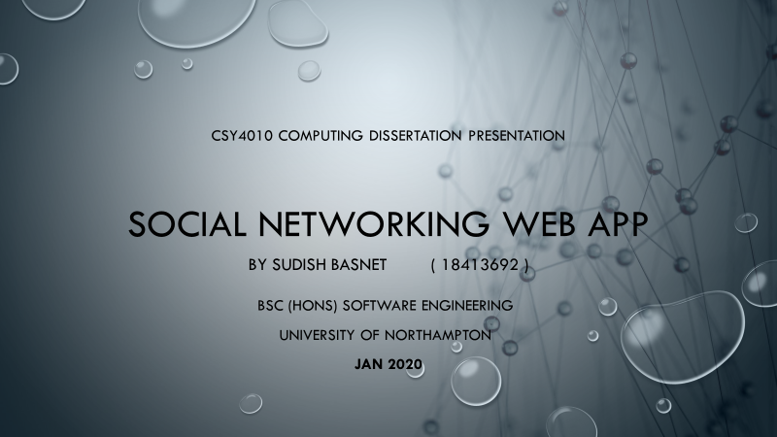

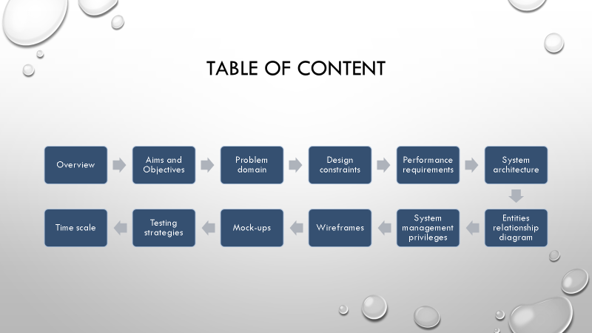

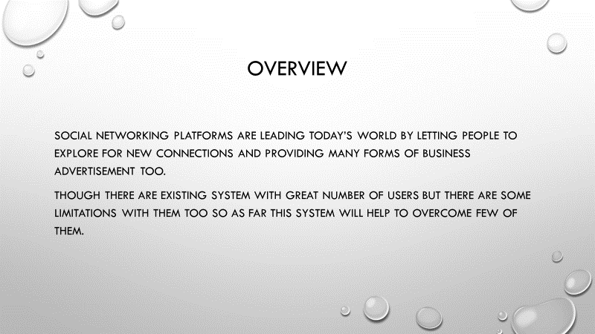

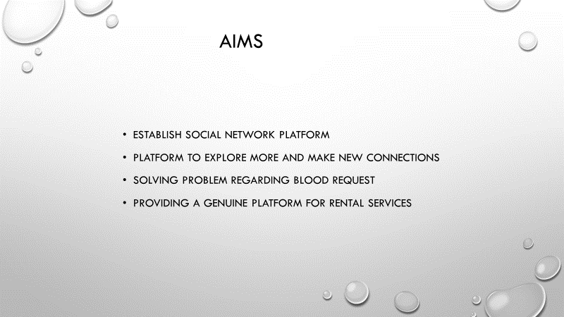

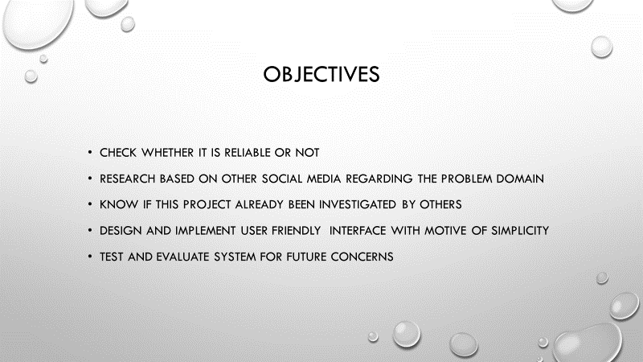

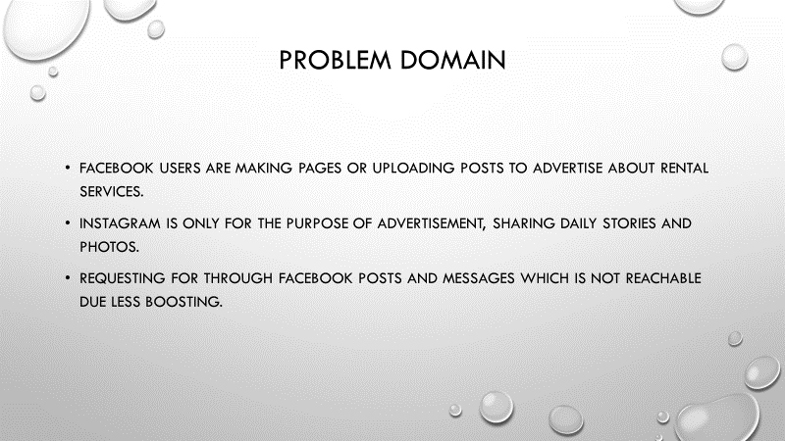

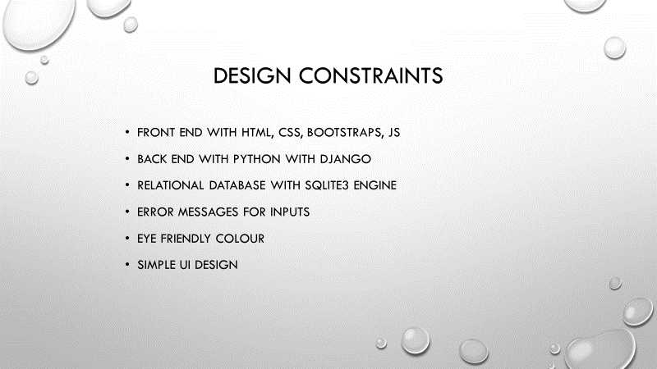

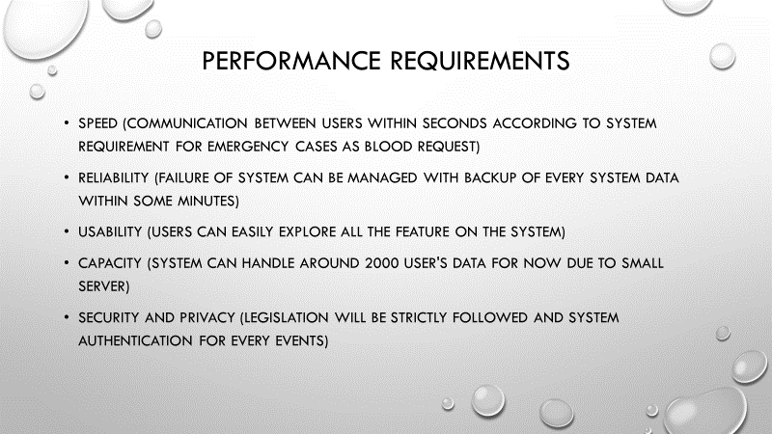

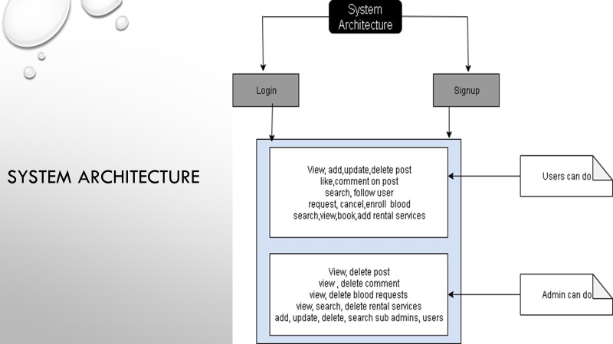

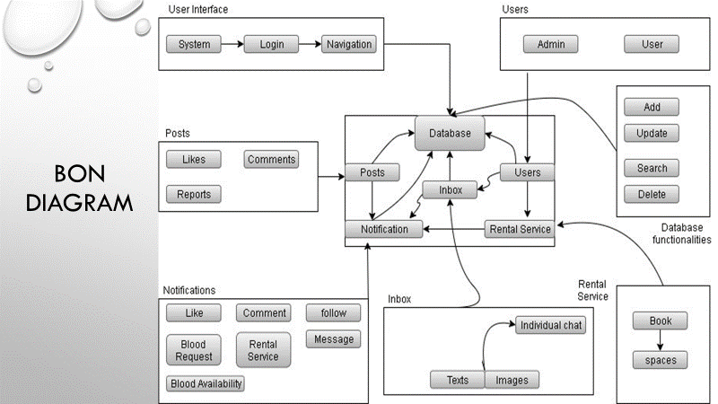

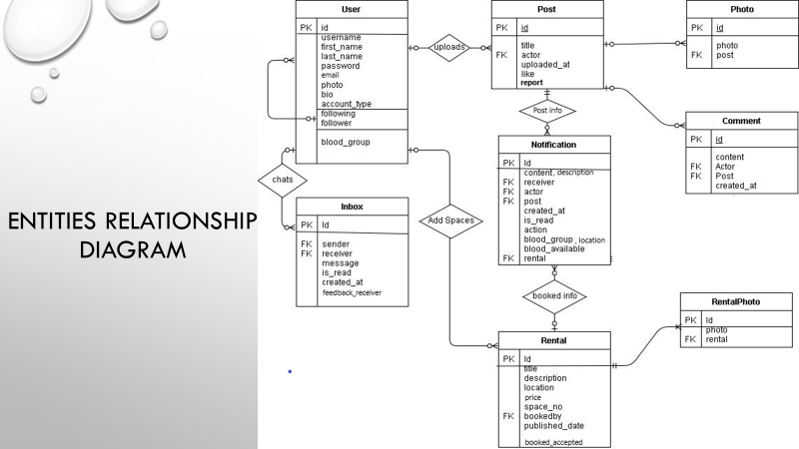

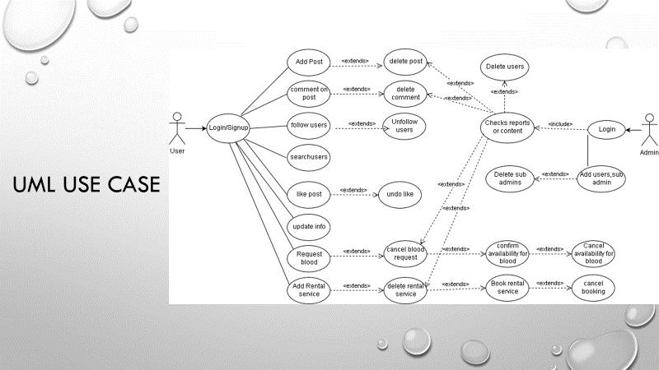

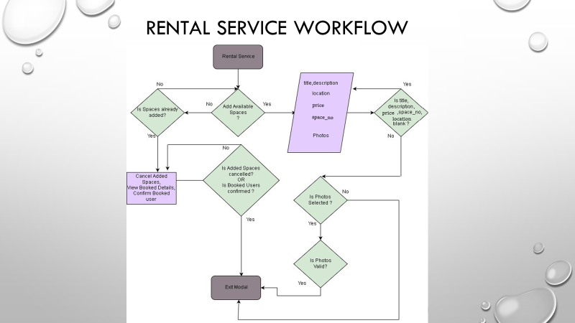

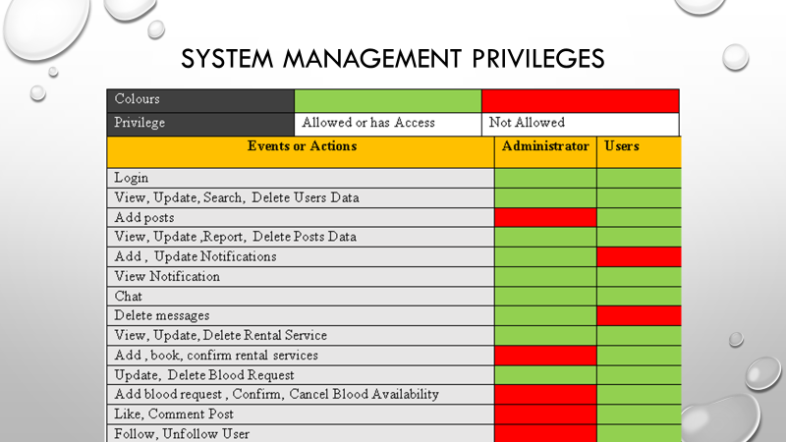

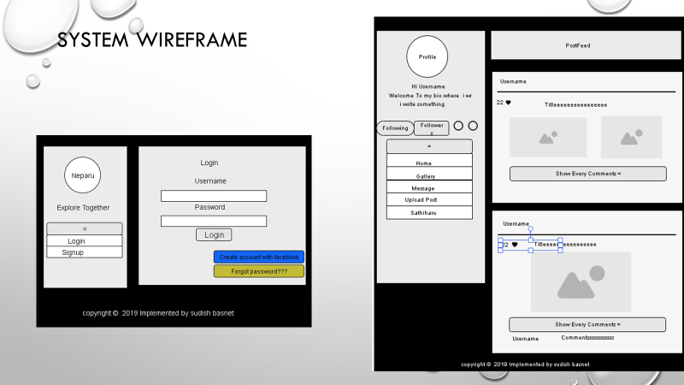

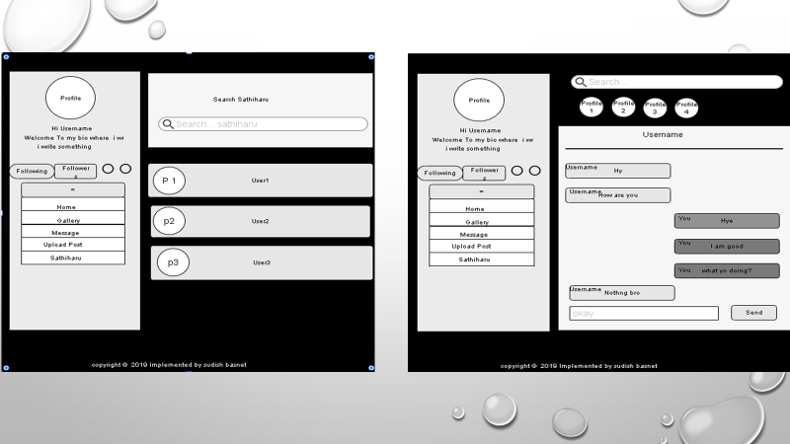

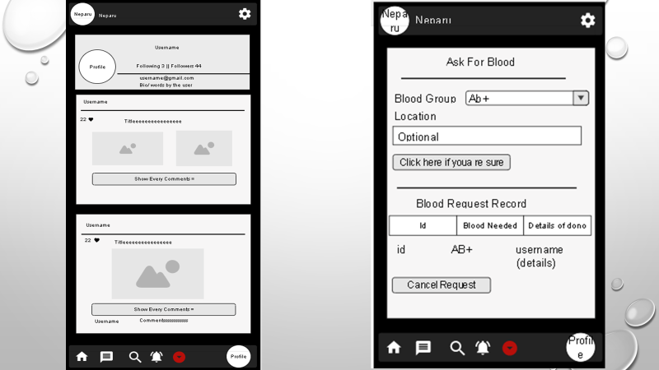

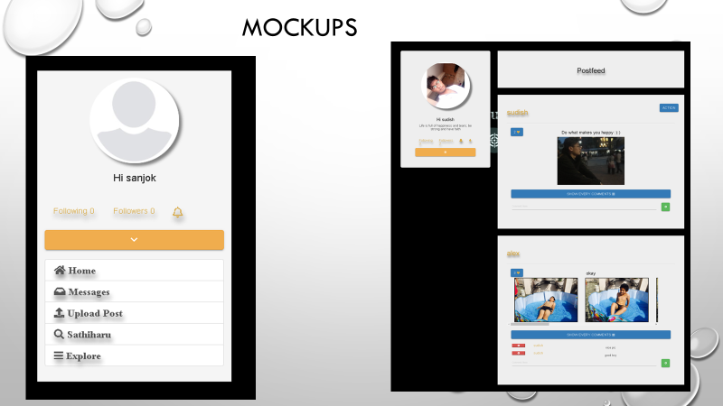

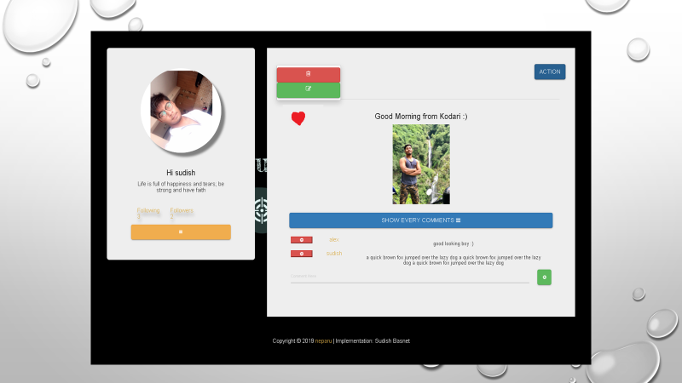

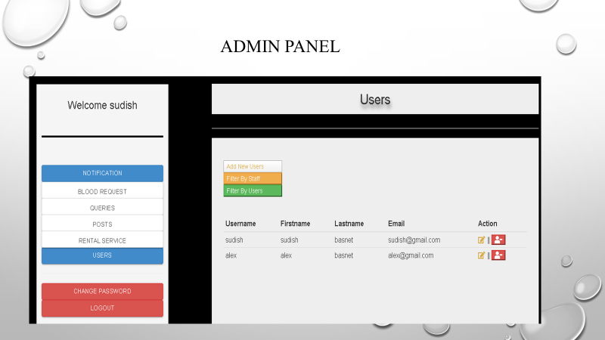

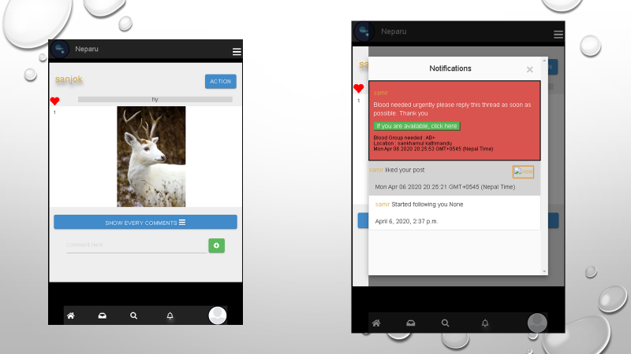

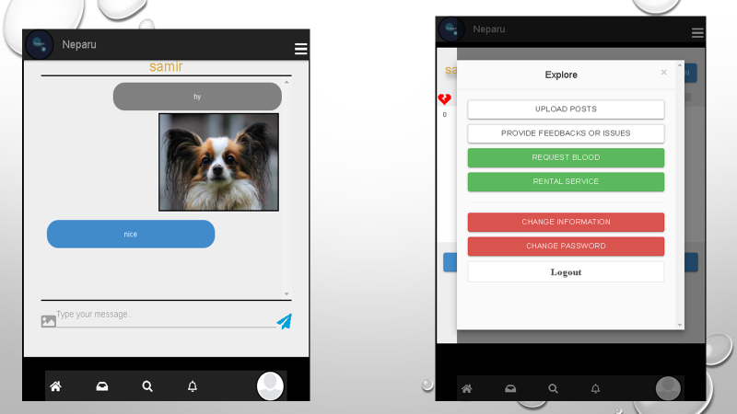

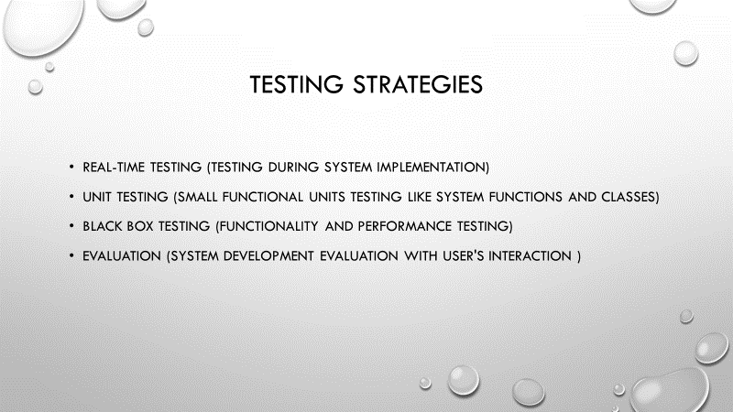

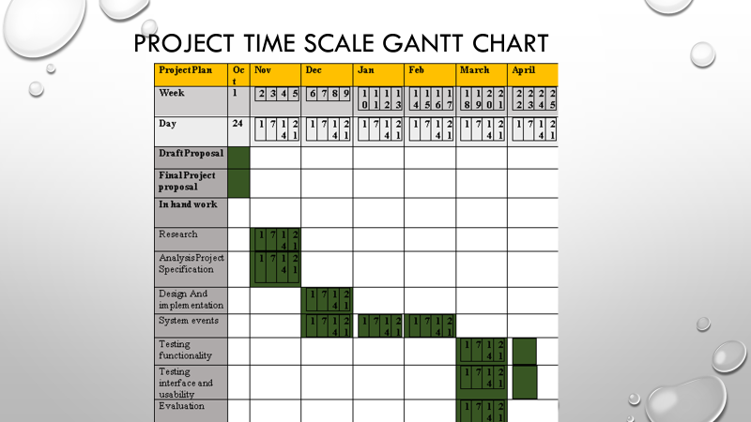



## 10.4. : Supervisor log

For the proper implementation of system and to meet the requirement starting with background research for knowing the real-life issues, several meetings with supervisor is done which allowed enough flexibility to complete this dissertation . Below is the supervisor log which were filled in between supervisor meeting sessions. There are not more logs as because of online communication with supervisor which was much more easier and faster to assign time routine for meetings and supervisor have given very positive response to the system development and report writing from initial stage of development to interim development and finally during the completion of development to ensure supervisor finds it satisfying. Supervisor have really appreciated the work done.

